Contents
1. Introduction 3
2. Assumptions & Design Rules 4
2.1 Layered Architecture Rules 4
2.2 Array-Based Persistence Requirement 4
2.3 External Services as Interfaces 4
2.4 Status Representation 4
2.5 Error Handling Style 4
2.6 Scope 4
3. Use Case Classification (Simple / Moderate / Complex) 5
3.1 Classification Criteria 5
3.2 Classification Summary 5
4. Selected 12 Core Use Cases (4 per category) 5
5. OO Design Method (Chapters 12 & 13) 6
6. Use Case Realizations (12 Use Cases) 6
6.1 UC-02 — Register Patient Information (Simple — CRC) 7
6.2 UC-06 — Cancel Appointment (Simple — CRC) 8
6.3 UC-09 — Send Appointment Reminders (Simple — CRC) 11
6.4 UC-T2 — Update Slot Availability (Simple — CRC) 13
6.5 UC-04 — Confirm Appointment Slot (Moderate — Communication) 14
6.6 UC-08 — Authorize Patient Discharge (Moderate — Communication) 16
6.7 UC-11 — Generate Monthly Bill (Moderate — Communication) 19
6.8 UC-T3 — Synchronize Patient Information (Moderate — Communication) 21
6.9 UC-01 — Book Appointment (Complex — Sequence) 23
6.10 UC-03 — Manage Doctor Schedule (Complex — Sequence) 24
6.11 UC-05 — Complete Patient Treatments (Complex — Sequence) 27
6.12 UC-07 — Make Payment (Complex — Sequence) 28
7. Final Consolidated Design Class Diagram (DCD) 29
8. Package Diagram (Architecture) 31
9. Implementation (StarUML → Java + Walking Skeleton, Arrays Only) 32
9.1 Model-to-Code Transformation 32
9.2 Implemented Use Cases 34
9.3 “Database Interaction” via Array-Based DAOs 35
10. Evidence Checklist (Screenshots) 37
11. Jira / GitHub Evidence 38
12. Conclusion 38

1. Introduction
This deliverable presents the detailed object-oriented design of the Healthcare Management System (HMS) using the use-case driven approach taught in Chapters 12 and 13. The design work proceeds use case by use case, transforming analysis artifacts prepared in earlier deliverables into design-level classes, responsibilities, and method signatures.
We classified the system’s use cases into simple, moderate, and complex categories. Based on the course requirement, we selected 12 core use cases (4 per category) and performed use case realizations. Each realization begins from a first-cut layered partition and then applies the required technique according to the use-case type:
- Simple: CRC (Class–Responsibility–Collaboration)
- Moderate: Multi-layer communication diagrams
- Complex: Multi-layer sequence diagrams
Finally, we performed StarUML model-to-code transformation (Java generation) and implemented a runnable walking skeleton in NetBeans for:
- UC-02 Register Patient Information
- UC-06 Cancel Appointment
Implementation follows strict three-layer architecture: View → Controller → DAO and uses array-based DAO persistence (no database), as instructed.

2. Assumptions & Design Rules

2.1 Layered Architecture Rules
- View Layer (ui) contains boundary/UI classes only.
- Controller Layer (controller) mediates all communication between View and other layers.
- Data Access Layer (dao) encapsulates persistence operations and simulated “database interaction”.
- Domain Layer (domain) contains entity classes representing business state.
- Direct View → DAO calls are forbidden.

2.2 Array-Based Persistence Requirement
“Database interaction” is satisfied using arrays stored inside DAO classes. Only DAO classes read/write these arrays.

2.3 External Services as Interfaces
External systems are represented as interfaces (NotificationService, PaymentGateway, ExternalPatientSystem) and invoked only from controller classes.

2.4 Status Representation
Statuses are modeled as strings (e.g., CANCELLED, CONFIRMED, PAID) for UML + implementation consistency.

2.5 Error Handling Style
Controllers return clear success/error outputs suitable for a walking skeleton. Alternate flows are handled through controller validation.

2.6 Scope
All 12 use cases are designed and realized. Implementation focuses only on UC-02 and UC-06.

3. Use Case Classification (Simple / Moderate / Complex)

3.1 Classification Criteria
- Simple: CRUD / single goal; limited collaborators; minimal alternate flows.
- Moderate: Multi-object collaboration across layers; validations; state changes.
- Complex: Many interacting objects/services; multiple alternate flows; orchestration and external integration.

3.2 Classification Summary
- Simple (CRC): UC-02, UC-06, UC-09, UC-T2
- Moderate (Communication): UC-04, UC-08, UC-11, UC-T3
- Complex (Sequence): UC-01, UC-03, UC-05, UC-07

4. Selected 12 Core Use Cases (4 per category)
UC ID | Use Case Name | Primary Actor | Category | Justification
UC-01 | Book Appointment | Patient / Receptionist | Complex | Orchestration + slot validation + alternate paths
UC-02 | Register Patient Information | Receptionist | Simple | CRUD + validation + persistence
UC-03 | Manage Doctor Schedule | Doctor | Complex | Conflict detection + schedule updates
UC-04 | Confirm Appointment Slot | Receptionist | Moderate | Status transition + validation + messaging
UC-05 | Complete Patient Treatments | Doctor | Complex | Record update + optional prescription + billing trigger
UC-06 | Cancel Appointment | Patient / Receptionist | Simple | Status update + rule checks + notification
UC-07 | Make Payment | Patient | Complex | External payment gateway + failure handling
UC-08 | Authorize Patient Discharge | Doctor | Moderate | Rule approval + record update + room release
UC-09 | Send Appointment Reminders | Scheduler | Simple | Scheduled notifications
UC-11 | Generate Monthly Bill | Scheduler | Moderate | Aggregation + bill creation + alternate flow
UC-T2 | Update Slot Availability | Scheduler | Simple | Scheduled scan + status update
UC-T3 | Synchronize Patient Information | Receptionist/System | Moderate | External sync + failure handling

5. OO Design Method (Chapters 12 & 13)
For each selected use case, we followed a consistent OO design loop:
- Build a first-cut partition (Boundary / Controller / Entity / DAO / External).
- Apply the required realization technique (CRC / Communication / Sequence).
- Extract messages from the realization and assign them to class operations.
- Update the DCD and repeat until the final DCD is complete and consistent with layering rules.

6. Use Case Realizations (12 Use Cases)
For each use case, we include:
- First-cut partition (Before)
- Realization diagram
- Updated partition (After)
- Extracted operations table

6.1 UC-02 — Register Patient Information (Simple — CRC)
Figures
- Figure 1: UC-02 First-Cut Design Class Diagram
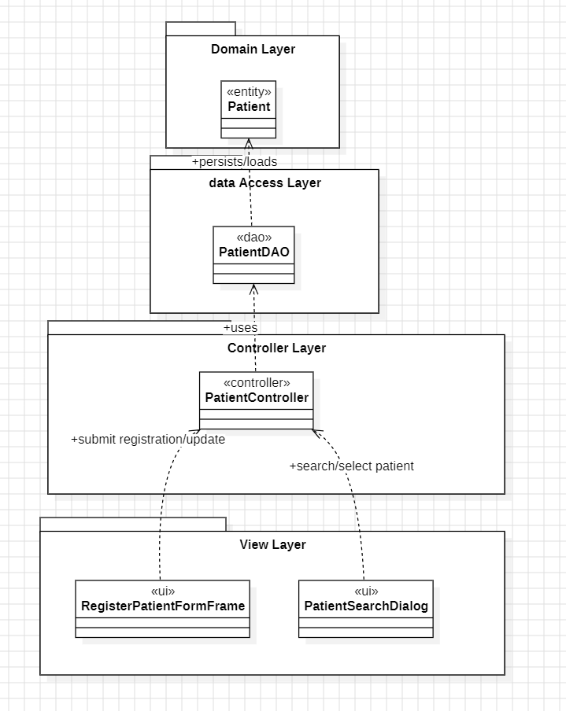
- Figure 2: UC-02 — CRC (Register patient information)
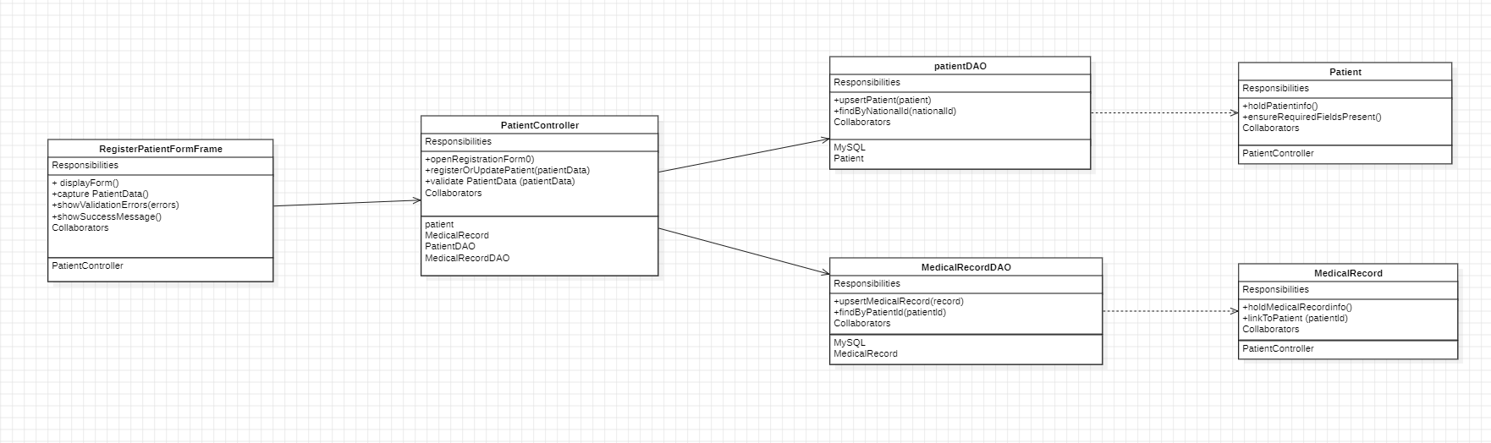
- Figure 3: UC-02 Updated Design Class Diagram.png
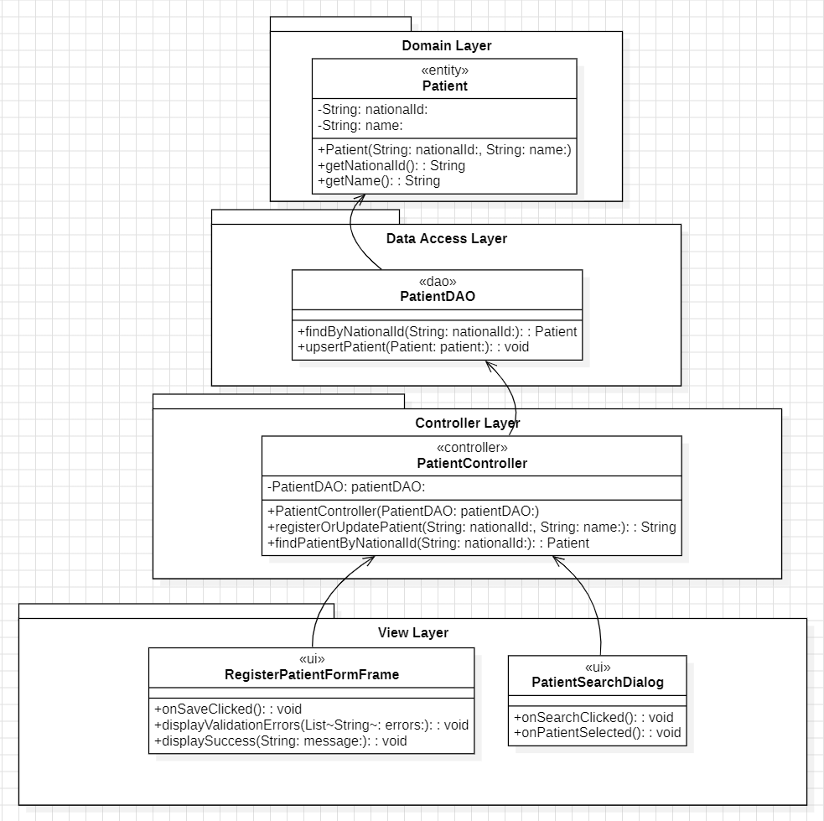
Extracted Operations Table (UC-02)
Step | Sender → Receiver | Assigned Class | Operation / Method Signature
1 | UI → Controller | PatientController | registerPatient(nationalId, name)
2 | Controller → DAO | PatientDAO | findByNationalId(nationalId)
3 | Controller → DAO | PatientDAO | saveOrUpdate(patient)
4 | Controller → UI | UI class | display success/error

6.2 UC-06 — Cancel Appointment (Simple — CRC)
Figures
- Figure 4: UC-06 First-Cut Design Class Diagram (Partition).png
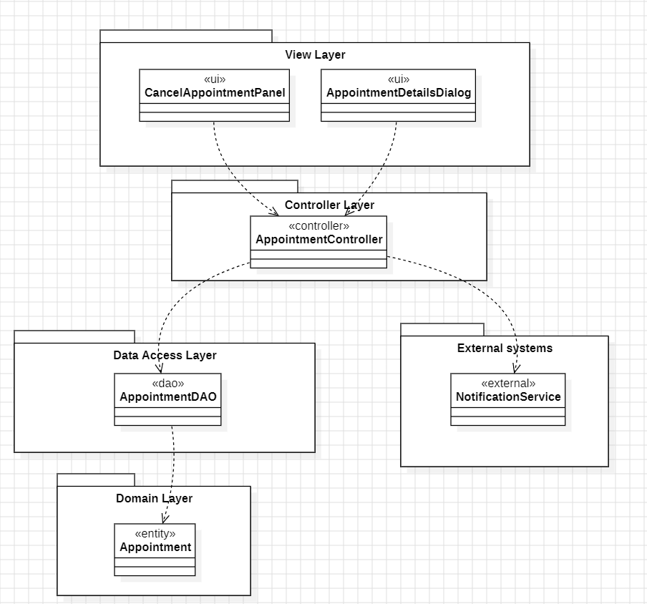
- Figure 5: UC-06 — CRC (Cancel appointment).png

- Figure 6: UC-06 Updated Design Class Diagram — AFTER CRC.png
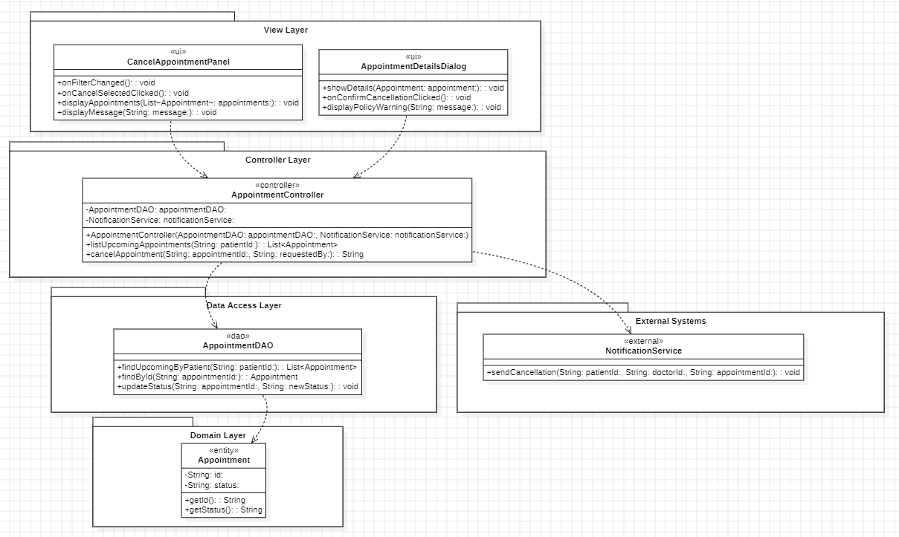
Extracted Operations Table (UC-06)
Step | Sender → Receiver | Assigned Class | Operation / Method Signature
1 | UI → Controller | AppointmentController | listUpcomingAppointments(patientNationalId)
2 | Controller → DAO | AppointmentDAO | findUpcomingByPatientNationalId(patientNationalId)
3 | UI → Controller | AppointmentController | cancelAppointment(appointmentId)
4 | Controller → DAO | AppointmentDAO | findById(appointmentId)
5 | Controller → DAO | AppointmentDAO | updateStatus(appointmentId, "CANCELLED")
6 | Controller → External | NotificationService | sendCancellation(message)

6.3 UC-09 — Send Appointment Reminders (Simple — CRC)
Figures
- Figure 7: UC-09 First-Cut Design Class Diagram (Partition).png
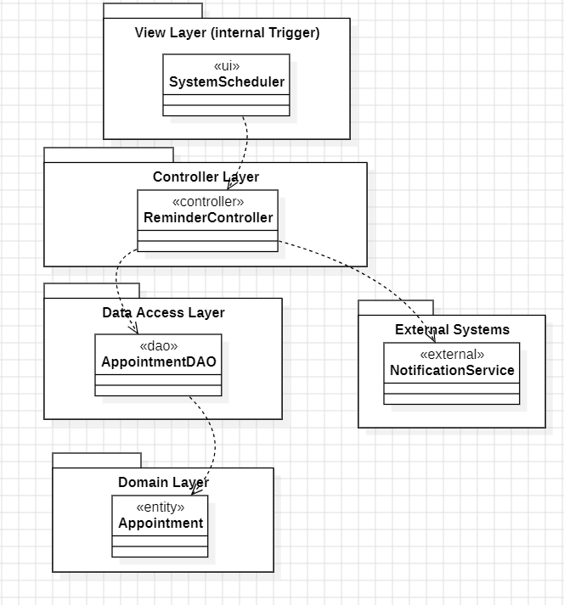
- Figure 8: UC-09 — CRC (Send appointment reminders).png
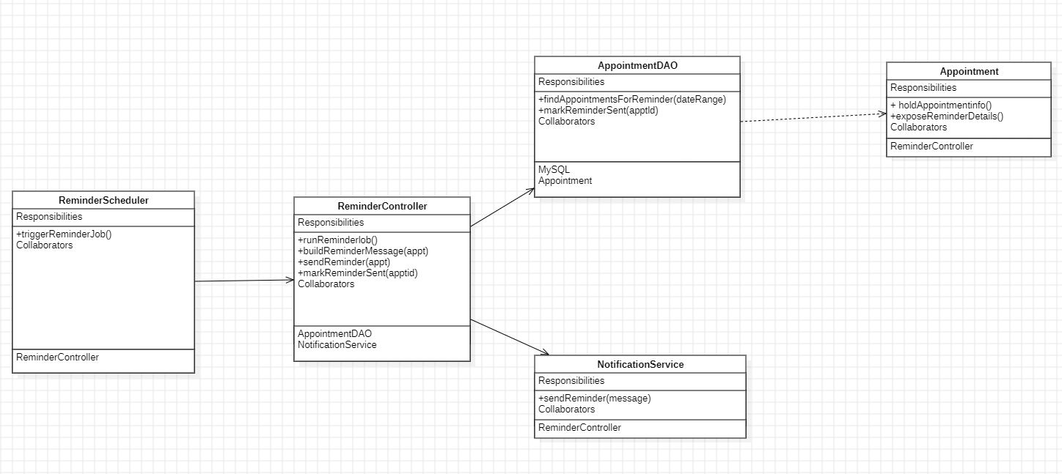
- Figure 9: UC-09 Updated Design Class Diagram — AFTER CRC.png
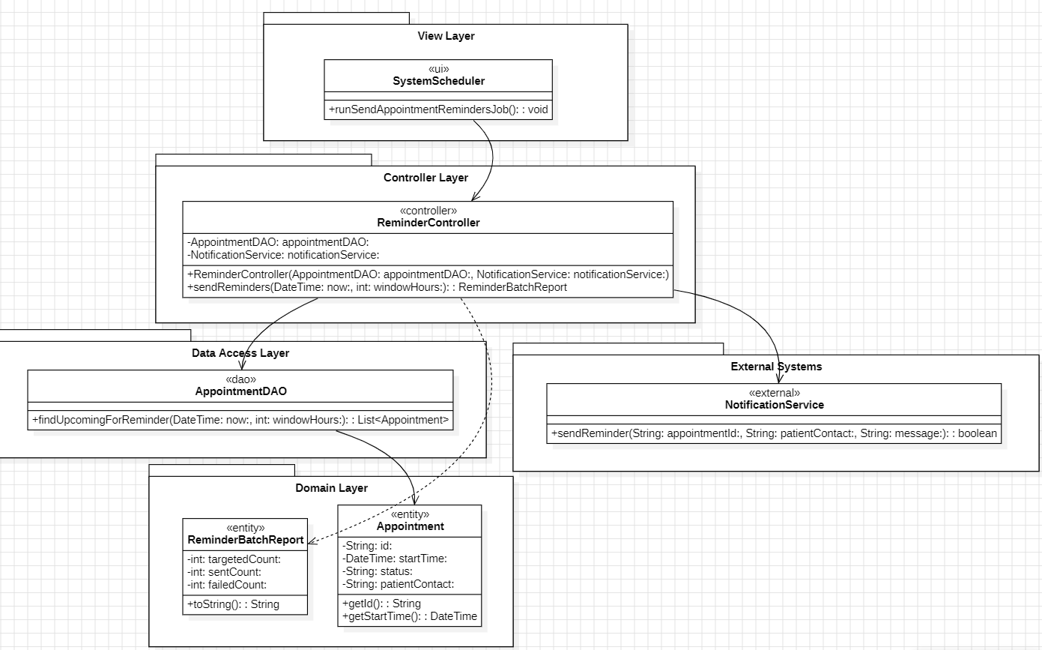
Extracted Operations Table (UC-09)
Step | Sender → Receiver | Assigned Class | Operation / Method Signature
1 | Scheduler → Controller | ReminderController | sendReminders(..)
2 | Controller → DAO | AppointmentDAO | findAppointmentsForReminder(..)
3 | Controller → External | NotificationService | send reminder message(s)

6.4 UC-T2 — Update Slot Availability (Simple — CRC)
Figures
- Figure 10: UC-T2 First-Cut Design Class Diagram (Partition).png
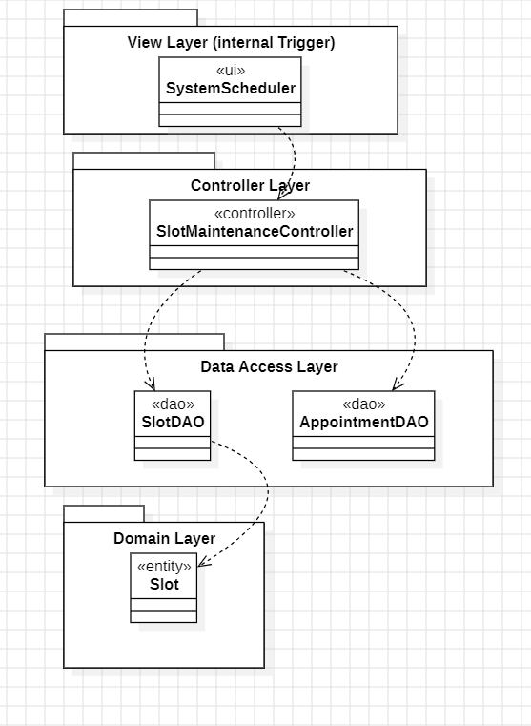
- Figure 11: UC-T2 — CRC (Update slot availability).png
- 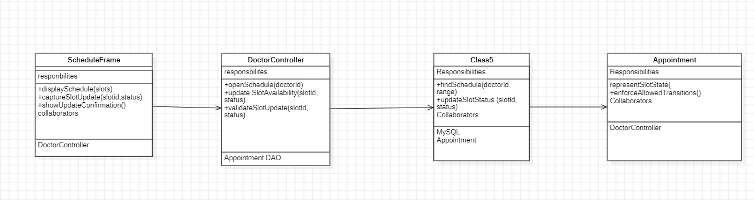
- Figure 12: UC-T2 Updated Design Class Diagram — AFTER CRC.png
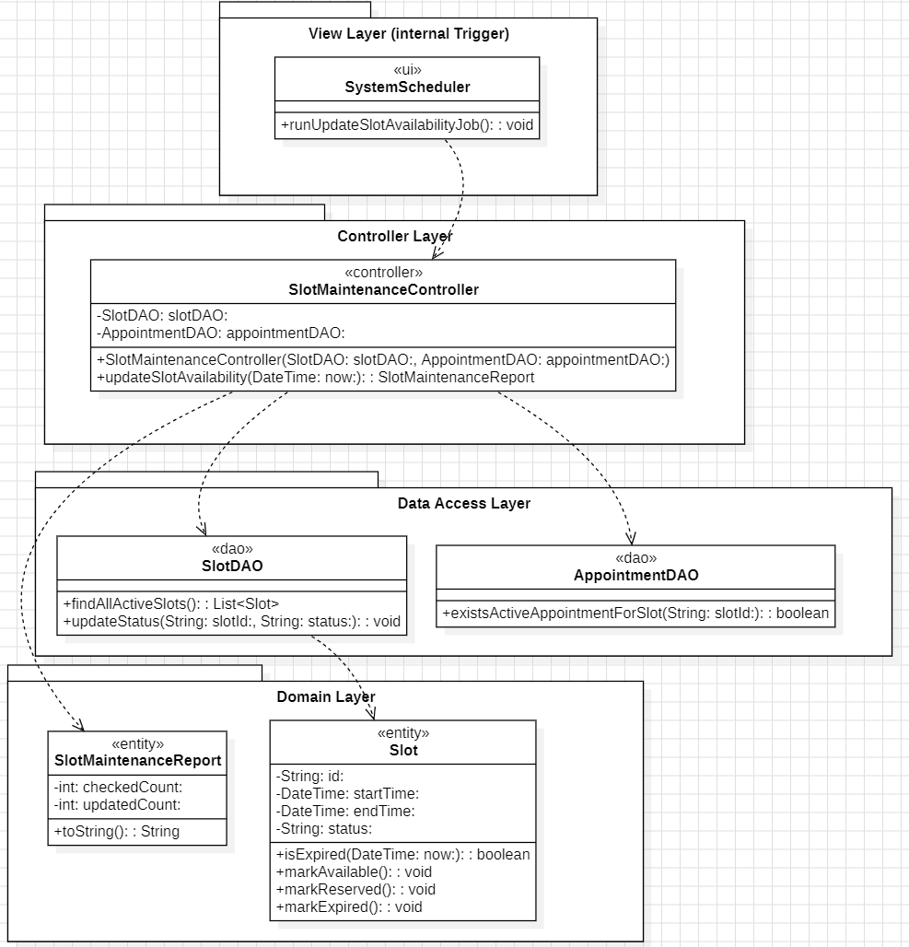
Extracted Operations Table (UC-T2)
Step | Sender → Receiver | Assigned Class | Operation / Method Signature
1 | Scheduler → Controller | SlotMaintenanceController | updateSlotAvailability(..)
2 | Controller → DAO | SlotDAO | findAllActiveSlots()
3 | Controller → DAO | SlotDAO | updateStatus(slotId,status)

6.5 UC-04 — Confirm Appointment Slot (Moderate — Communication)
Figures
- Figure 13: UC-04 First-Cut Design Class Diagram (Partition).png
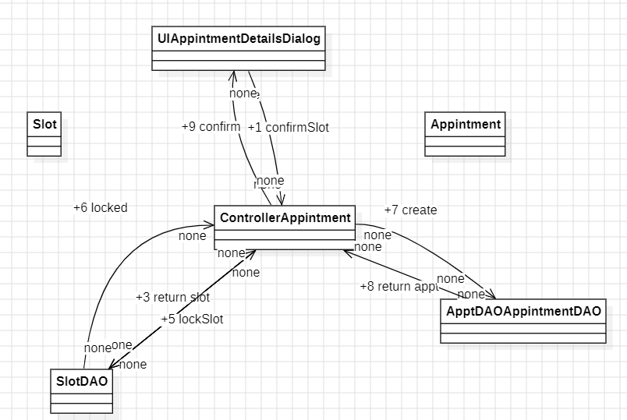
- Figure 14: UC-04 Confirm appointment slot.png
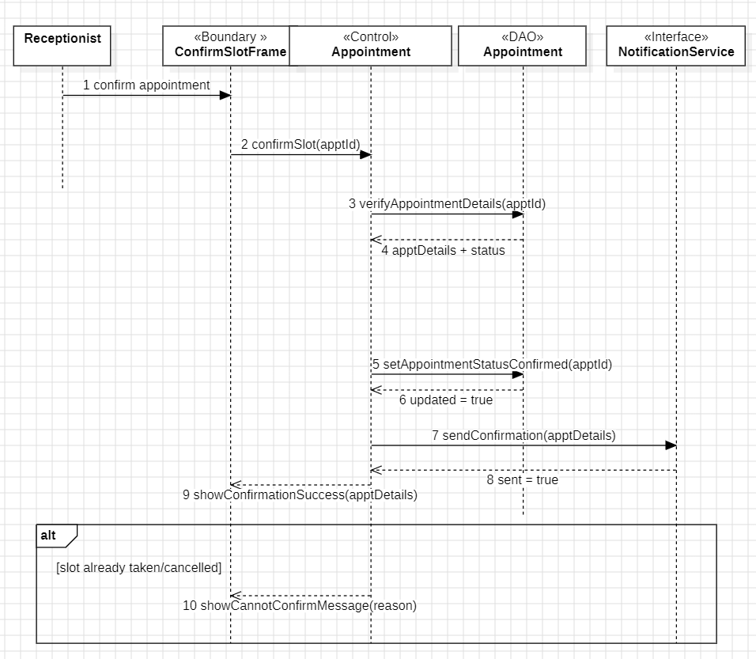
- Figure 15: UC-04 Updated Design Class Diagram — AFTER communication diagram.png

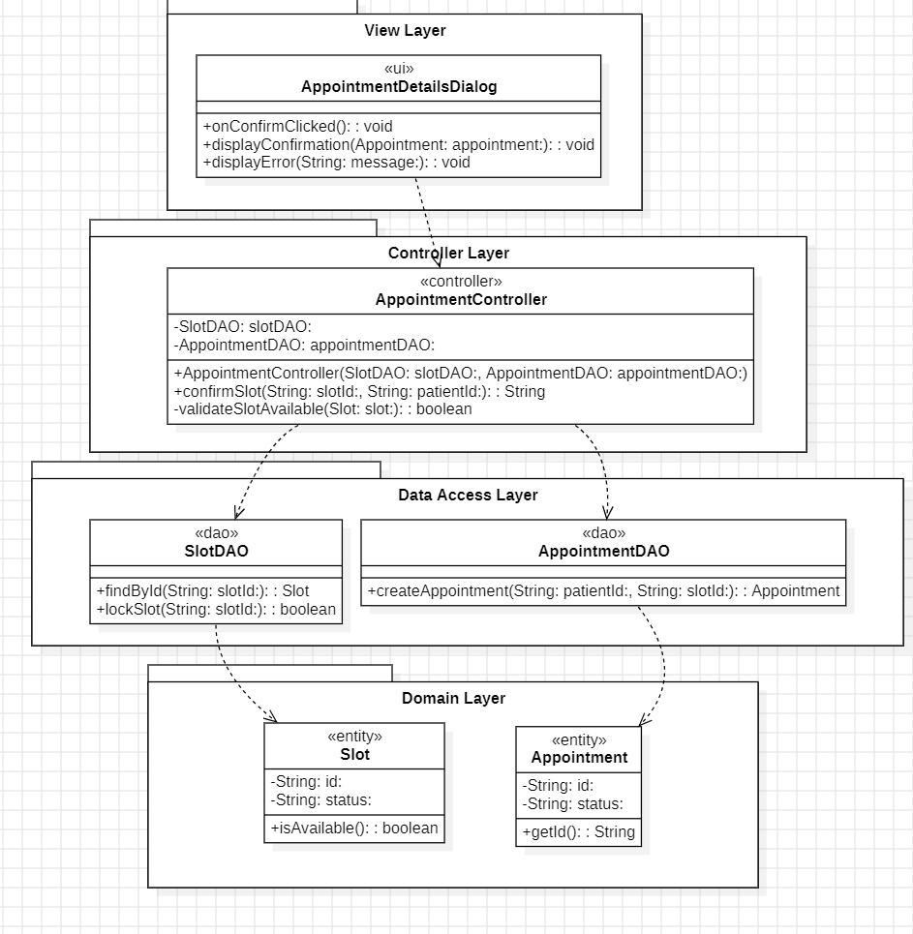
Extracted Operations Table (UC-04)
Message | Sender → Receiver | Assigned Class | Operation / Method Signature
1 | UI → Controller | AppointmentController | confirmSlot(appointmentId)
2 | Controller → DAO | AppointmentDAO | verify + update status confirmed
3 | Controller → External | NotificationService | send confirmation

6.6 UC-08 — Authorize Patient Discharge (Moderate — Communication)
Figures
- Figure 16: UC-08 Multi-Layer Communication Diagram.png
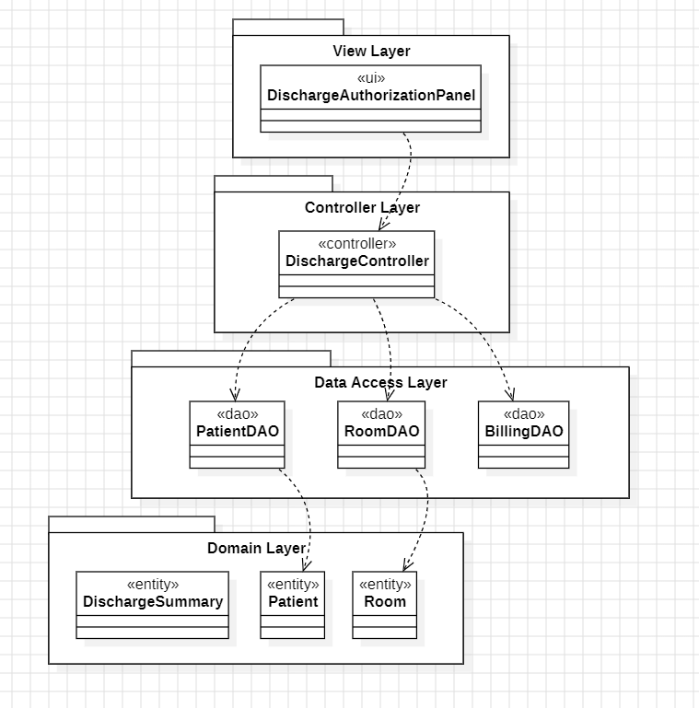
- Figure 17: UC-08 Authorize patient discharge.png
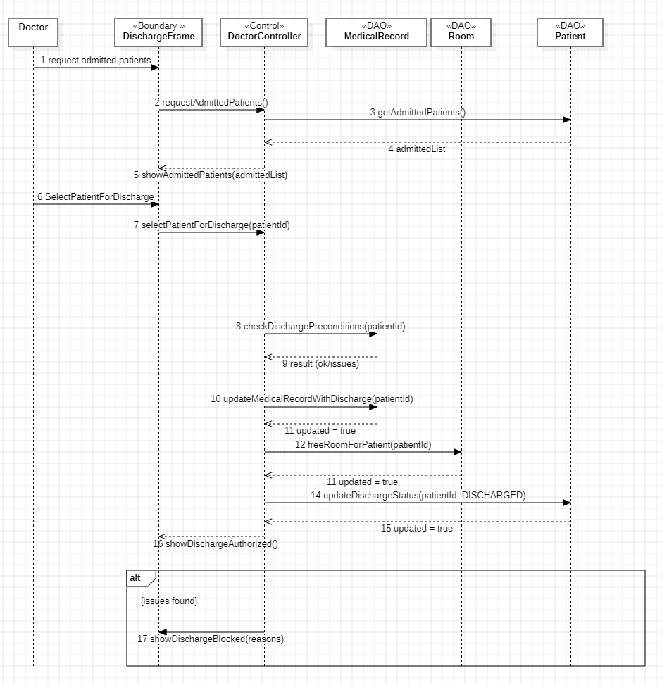
- Figure 18: UC-08 Updated Design Class Diagram — AFTER communication diagram.png
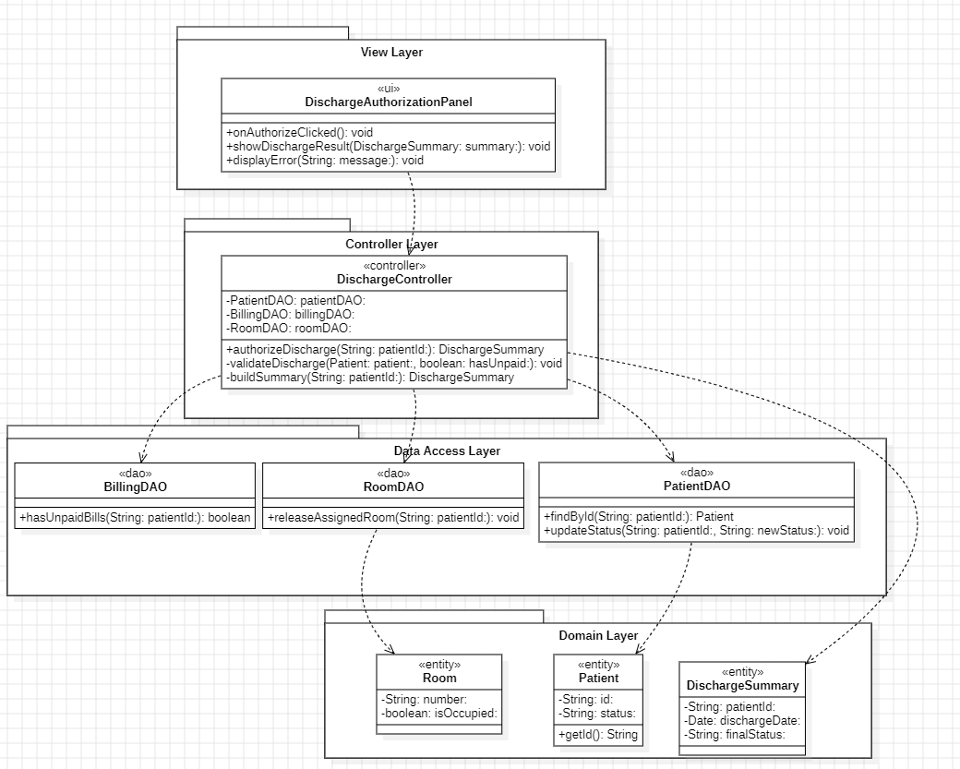
Extracted Operations Table (UC-08)
Message | Sender → Receiver | Assigned Class | Operation / Method Signature
1 | UI → Controller | DischargeController | authorizeDischarge(patientId)
2 | Controller → DAO | MedicalRecordDAO | checkDischargePreconditions(patientId)
3 | Controller → DAO | MedicalRecordDAO | updateMedicalRecordWithDischarge(patientId)
4 | Controller → DAO | RoomDAO | freeRoomForPatient(patientId)
5 | Controller → DAO | PatientDAO | updateDischargeStatus(patientId,status)

6.7 UC-11 — Generate Monthly Bill (Moderate — Communication)
Figures
- Figure 19: UC-11 Updated Design Class Diagram (Partition).png
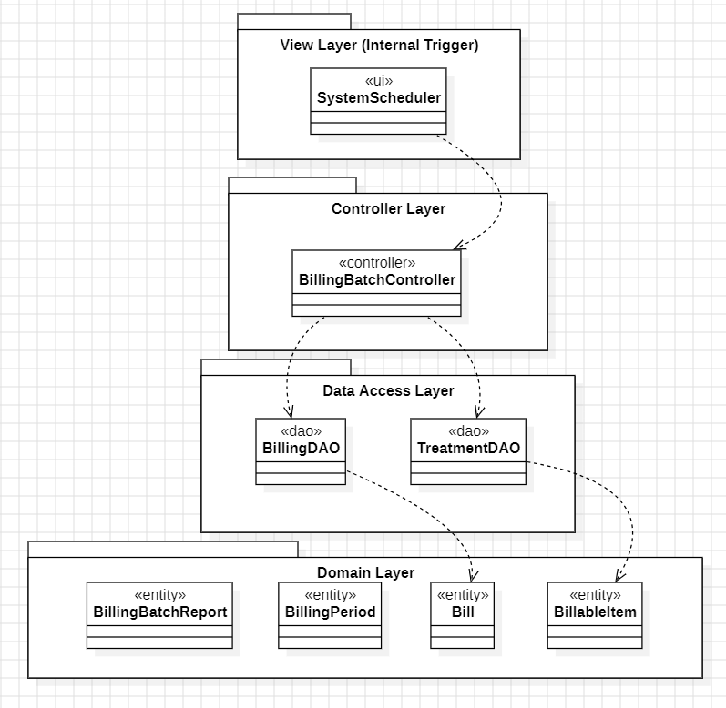
- Figure 20: UC-11 Generate Monthly Bill — Communication.png
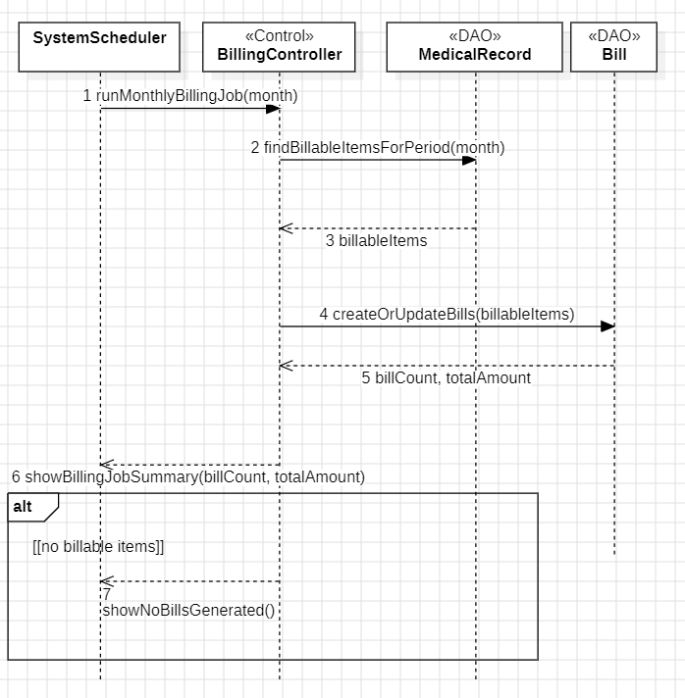
- Figure 21: UC-11 Updated Design Class Diagram — AFTER communication diagram.png

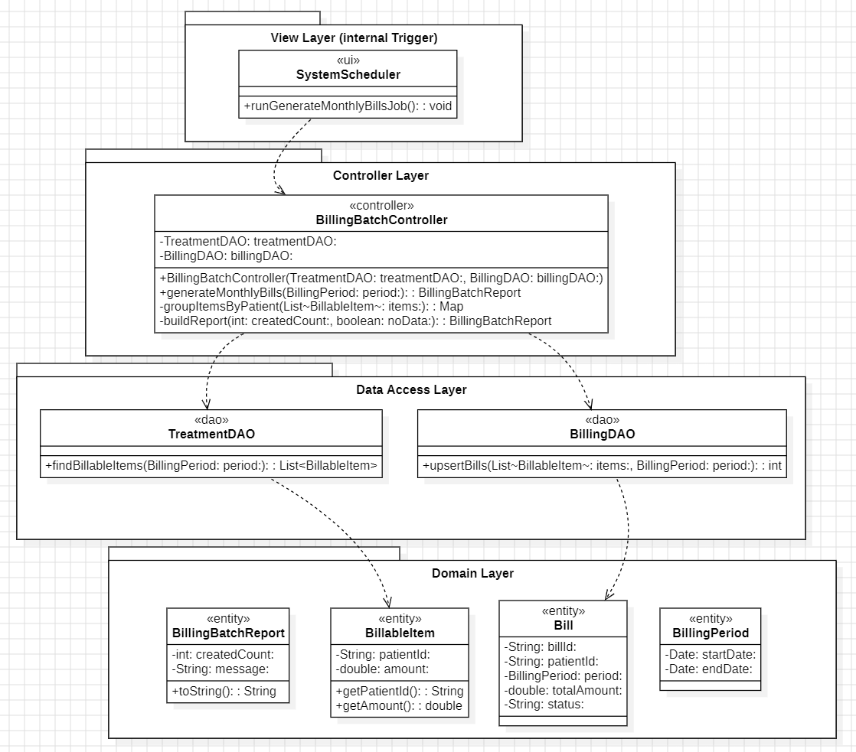
Extracted Operations Table (UC-11)
Message | Sender → Receiver | Assigned Class | Operation / Method Signature
1 | Scheduler → Controller | BillingController | generateMonthlyBills(period)
2 | Controller → DAO(s) | DAO(s) | retrieve billable items
3 | Controller → Domain | Bill | calculate totals
4 | Controller → DAO | BillDAO | create/update bills
Alt | Controller | BillingController | handle “no bills generated”

6.8 UC-T3 — Synchronize Patient Information (Moderate — Communication)
Figures
- Figure 22: UC-T3 First-Cut Design Class Diagram (Partition).png
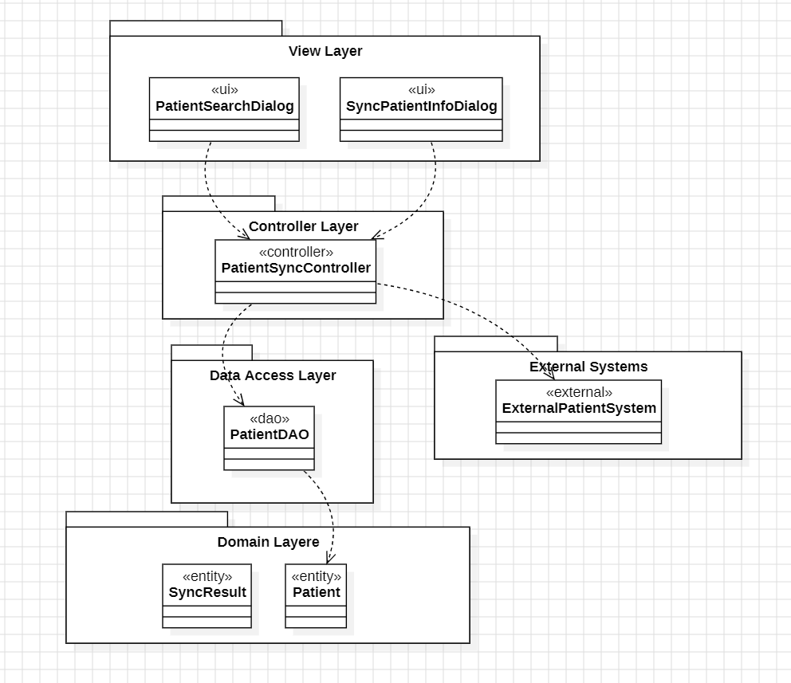
- Figure 23: UC-T3 Synchronize patient information.png
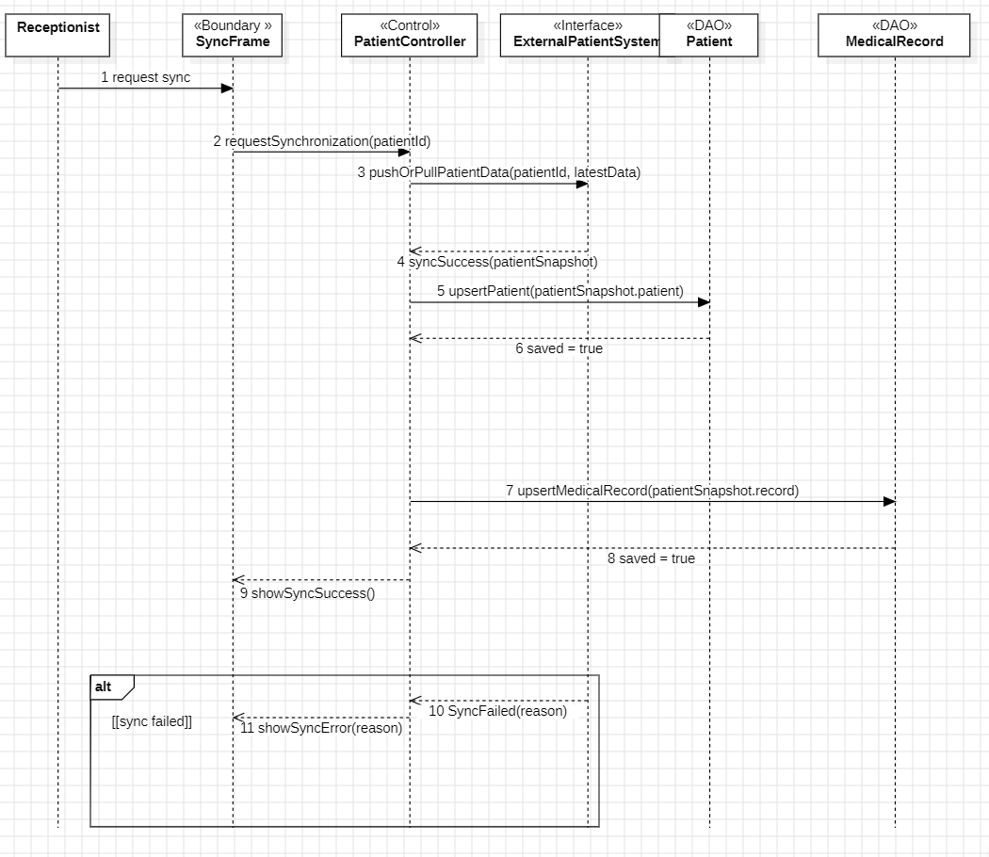
- Figure 24: UC-T3 Updated Design Class Diagram — AFTER communication diagram.png

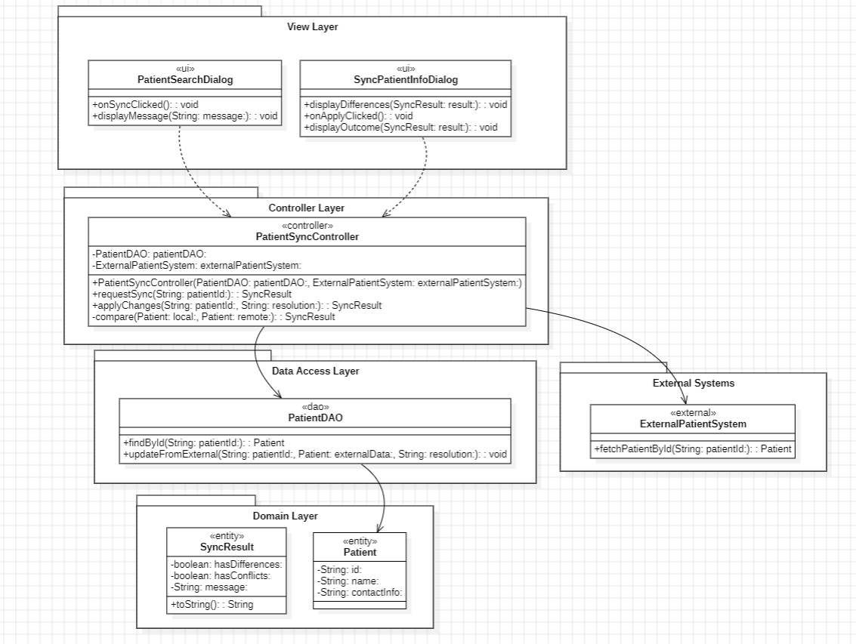

Extracted Operations Table (UC-T3)
Message | Sender → Receiver | Assigned Class | Operation / Method Signature
1 | UI → Controller | PatientController | start synchronization
2 | Controller → External | ExternalPatientSystem | fetch patient snapshot
3 | Controller → DAO | PatientDAO | upsert patient
4 | Controller → DAO | MedicalRecordDAO | upsert record
Alt | Controller → UI | UI class | show sync error

6.9 UC-01 — Book Appointment (Complex — Sequence)
Figures
- Figure 25: UC-01 First-Cut Design Class Diagram (Partition).png
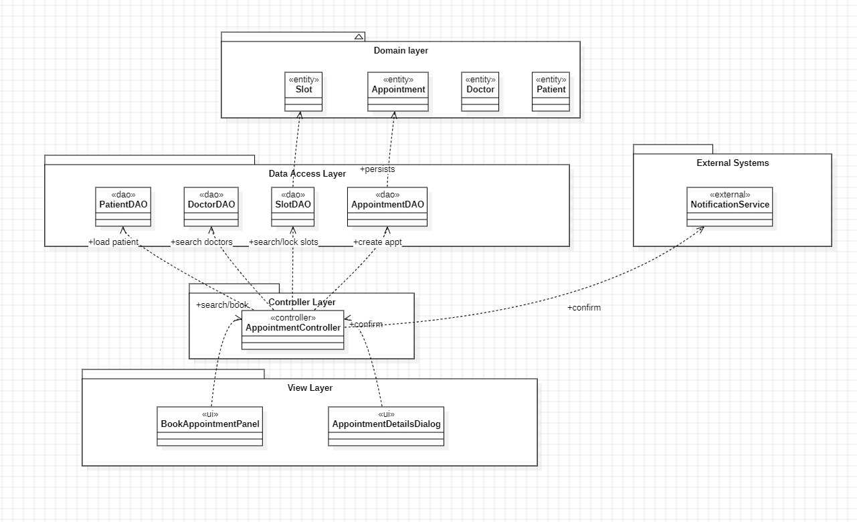
- Figure 26: UC-01 Book appointment.png
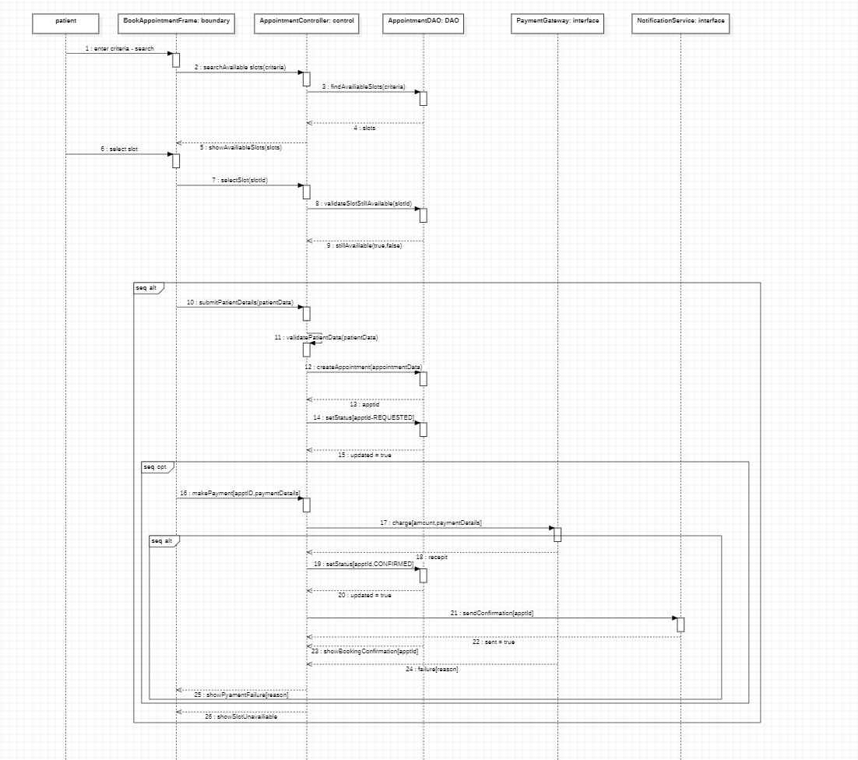
- Figure 27: UC-01 First-Cut Design Class Diagram — AFTER sequence diagram.png
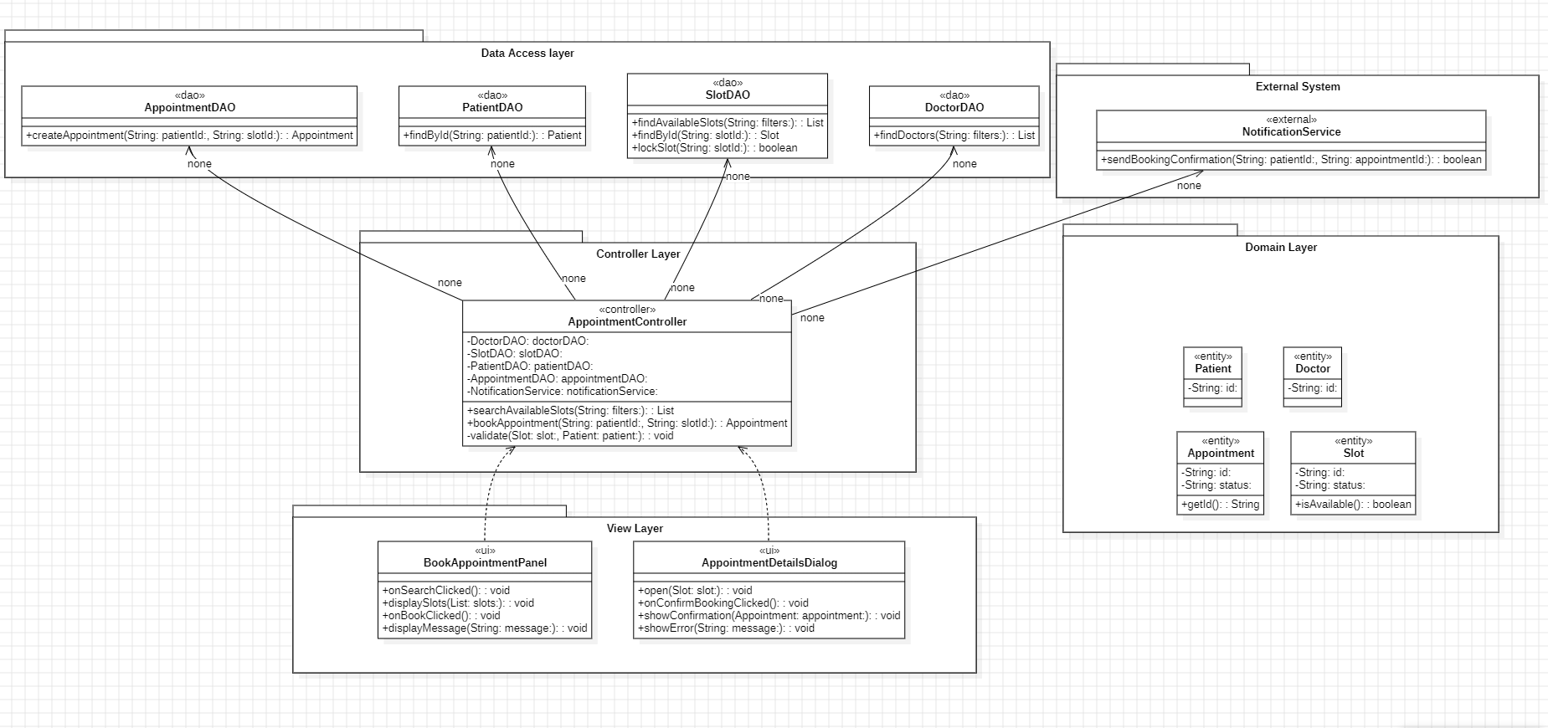
Extracted Operations Table (UC-01)
Step | Sender → Receiver | Assigned Class | Operation / Method Signature
1 | UI → Controller | AppointmentController | search/select slot
2 | Controller → DAO | DAO(s) | validate availability + create appointment
3 | Controller → External | NotificationService | send confirmation

6.10 UC-03 — Manage Doctor Schedule (Complex — Sequence)
Figures
- Figure 28: UC-03 First-Cut Design Class Diagram (Partition).png
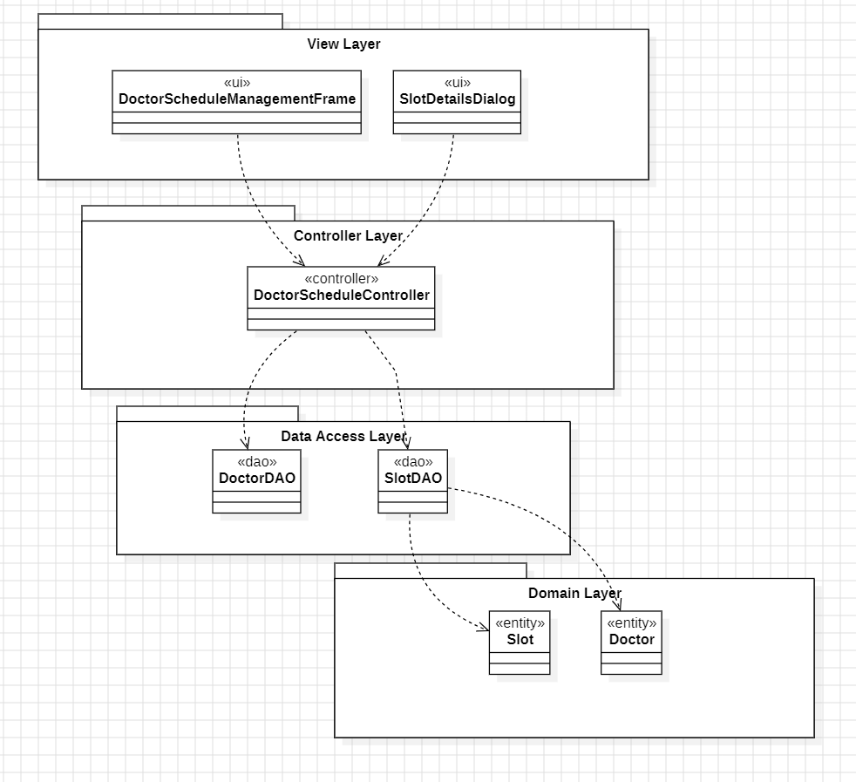
- Figure 29: UC-03 Manage doctor schedule.png
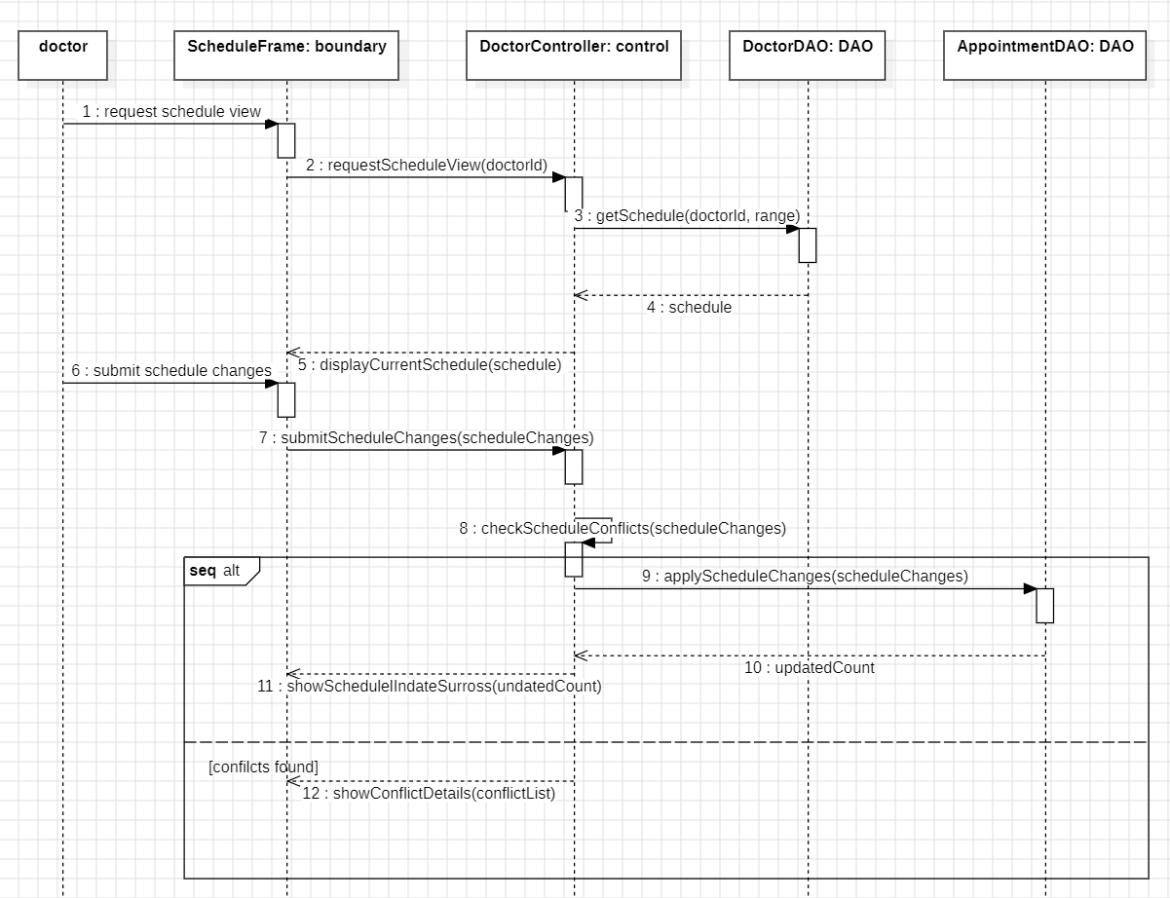
- Figure 30: UC-03 First-Cut Design Class Diagram — AFTER sequence diagram.png
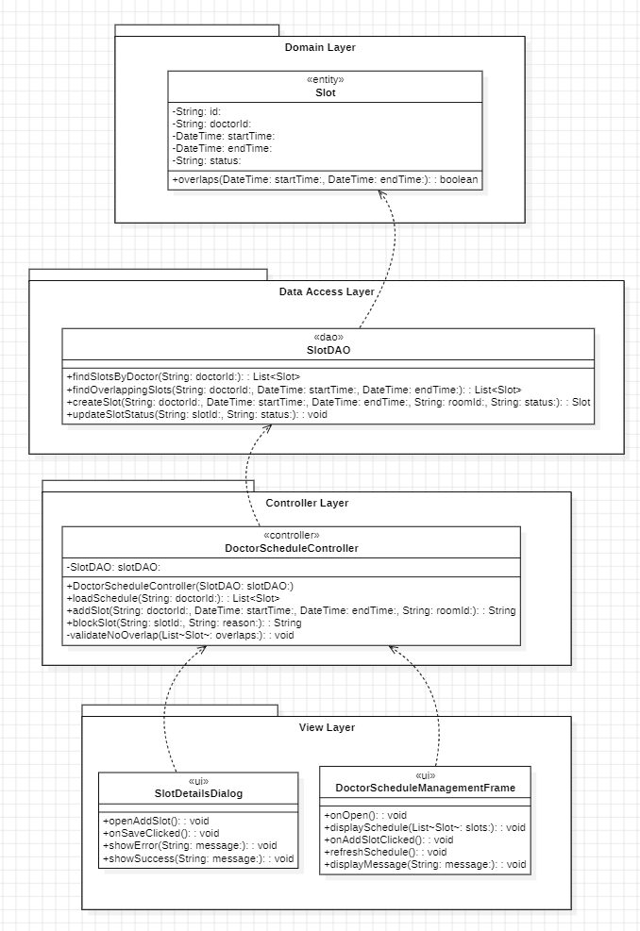
Extracted Operations Table (UC-03)
Step | Sender → Receiver | Assigned Class | Operation / Method Signature
1 | UI → Controller | DoctorScheduleController | open schedule
2 | Controller → DAO | DAO(s) | load schedule
3 | UI → Controller | DoctorScheduleController | propose changes
4 | Controller → Controller | DoctorScheduleController | detect conflicts
5 | Controller → DAO | SlotDAO | persist changes

6.11 UC-05 — Complete Patient Treatments (Complex — Sequence)
Figures
- Figure 31: UC-05 First-Cut Design Class Diagram (Partition).png
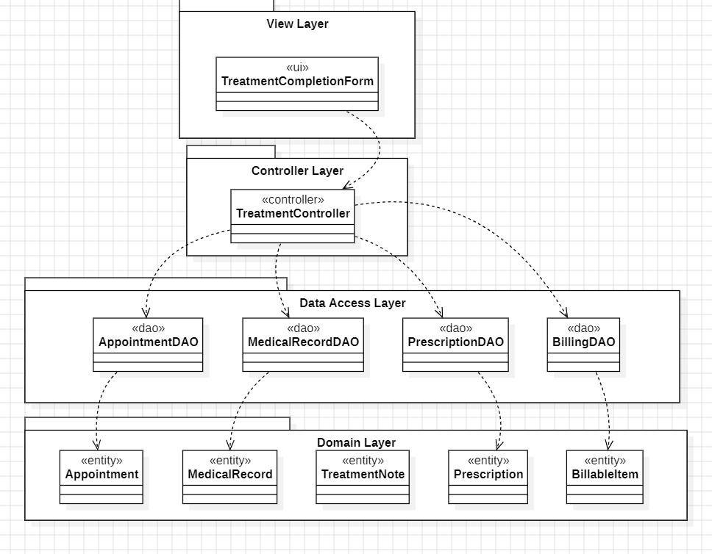
- Figure 32: UC-05 Complete patient treatments.png
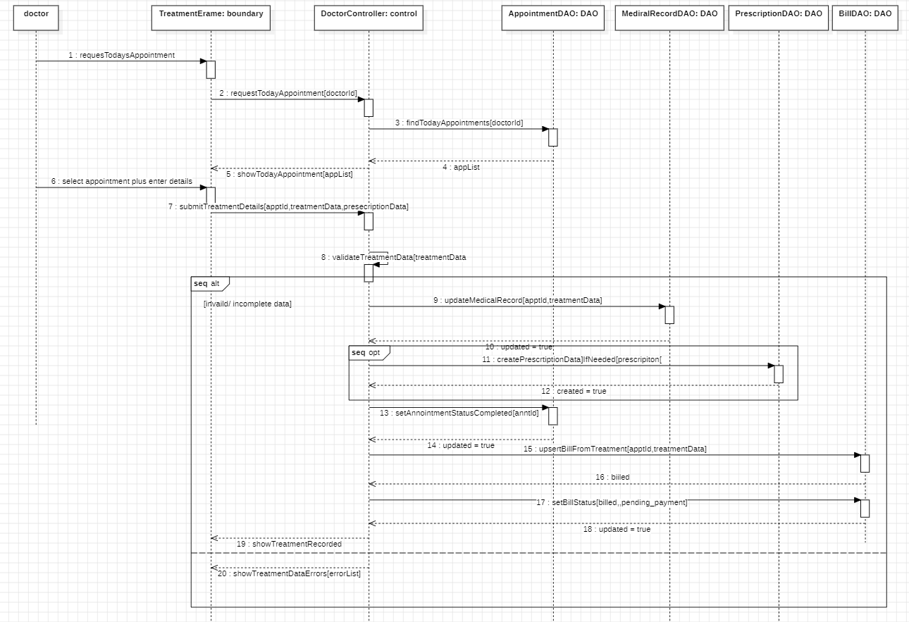
- Figure 33: UC-05 First-Cut Design Class Diagram — AFTER sequence diagram.png
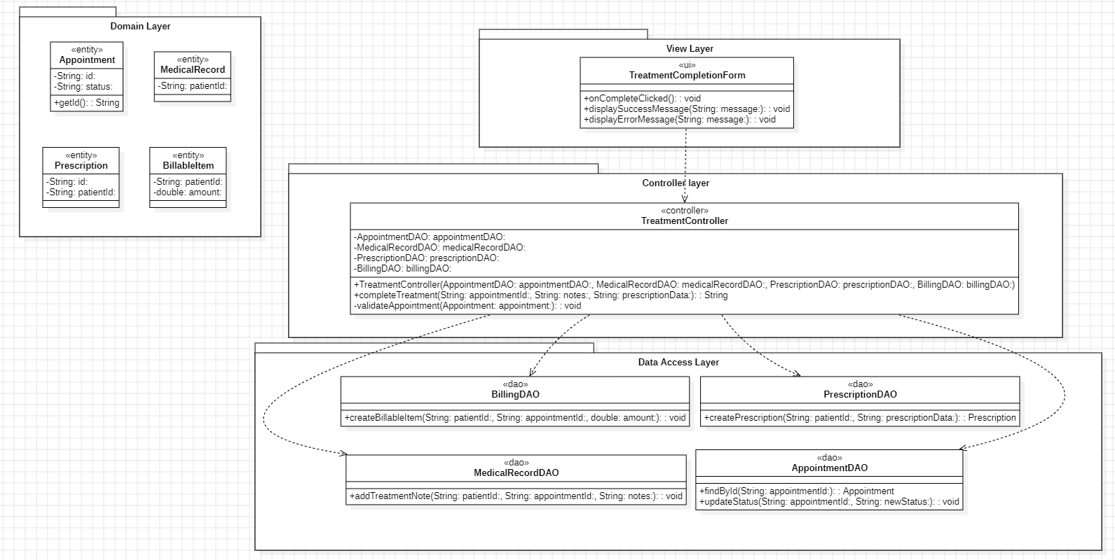
Extracted Operations Table (UC-05)
Step | Sender → Receiver | Assigned Class | Operation / Method Signature
1 | UI → Controller | TreatmentController | complete treatment
2 | Controller → DAO | MedicalRecordDAO | update record
3 | Controller → DAO | PrescriptionDAO | optional prescription
4 | Controller → DAO | BillDAO | trigger billing

6.12 UC-07 — Make Payment (Complex — Sequence)
Figures
- Figure 34: UC-07 First-Cut Design Class Diagram (Partition).png
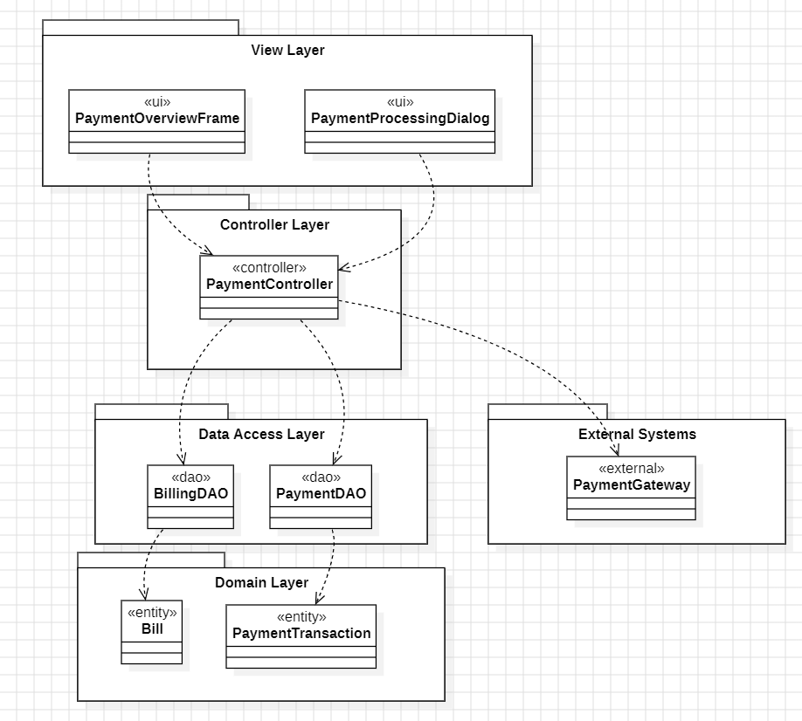
- Figure 35: UC-07 Make payment.png
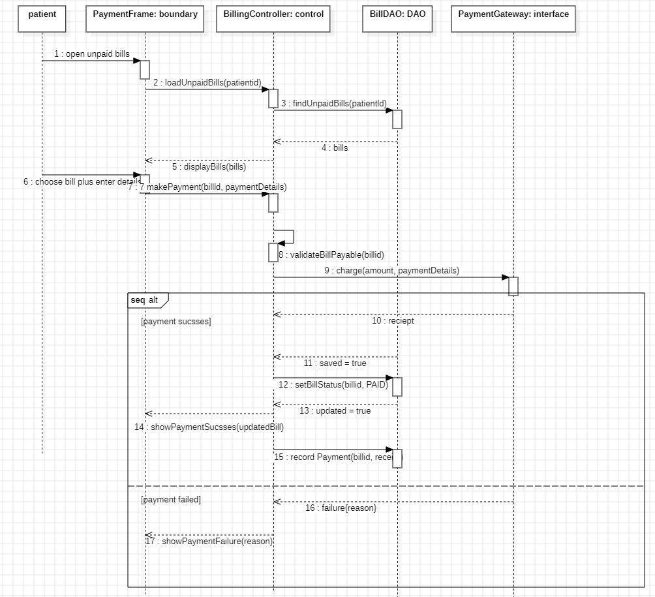
- Figure 36: UC-07 First-Cut Design Class Diagram — AFTER sequence diagram.png
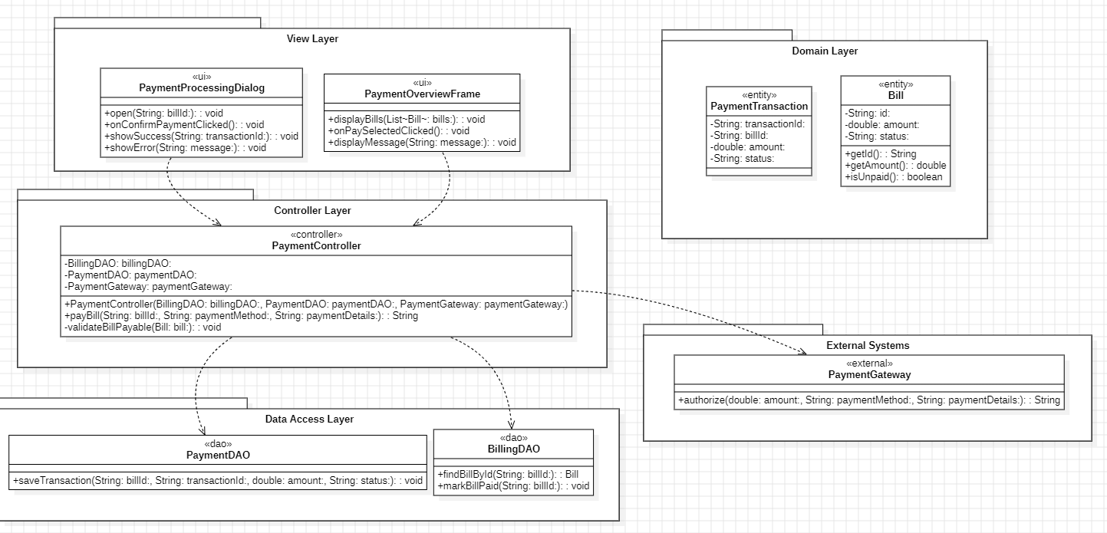
Extracted Operations Table (UC-07)
Step | Sender → Receiver | Assigned Class | Operation / Method Signature
1 | UI → Controller | PaymentController | make payment
2 | Controller → DAO | BillDAO | load unpaid bills
3 | Controller → External | PaymentGateway | charge payment
4 | Controller → DAO | BillDAO | record payment + update status

7. Final Consolidated Design Class Diagram (DCD)
Figure
- Figure 37: Final Design Class Diagram.png
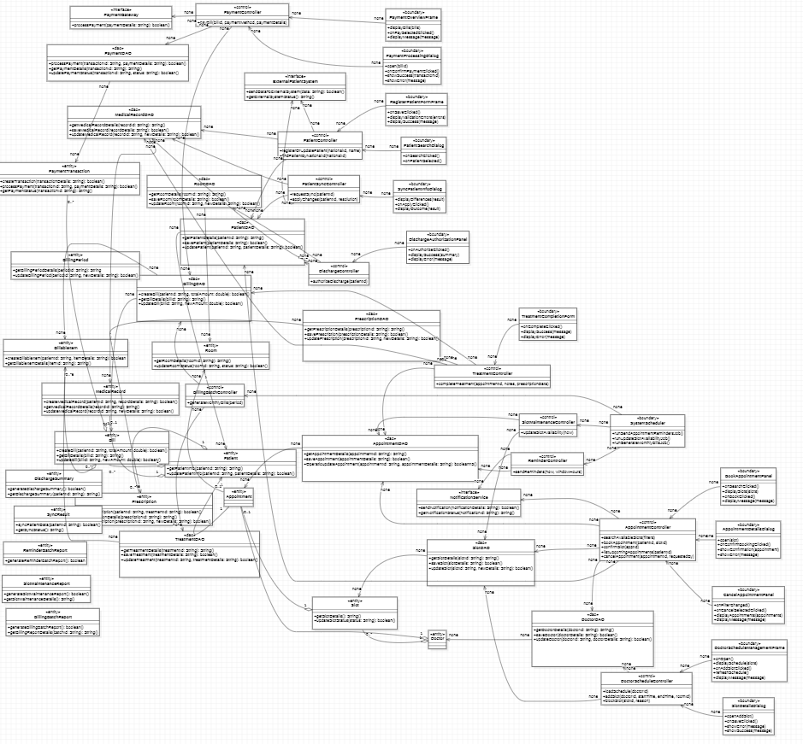
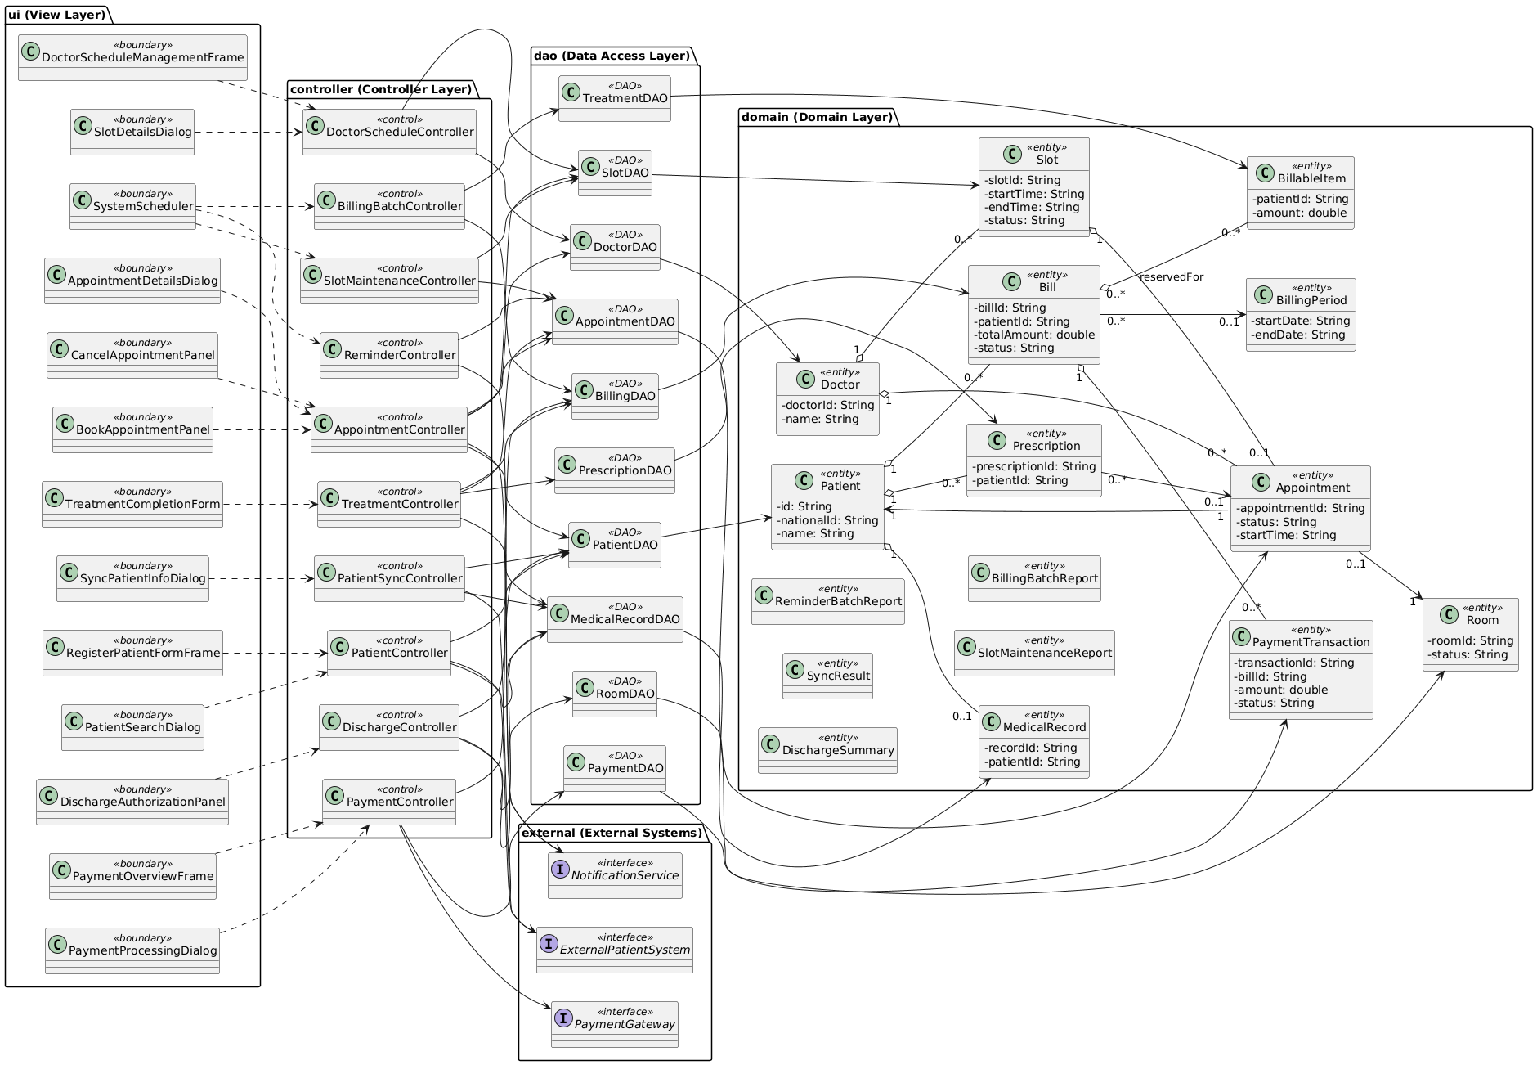
The final DCD consolidates all discovered classes and operations from the 12 realizations and enforces layered responsibilities.

8. Package Diagram (Architecture)
Figure
- Figure 38: Package Diagram.png
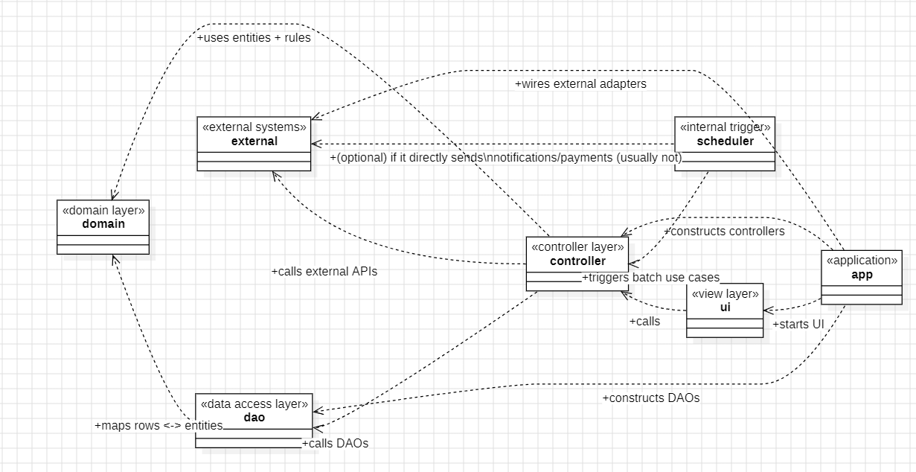
The package diagram documents the final architecture dependency direction:
- ui → controller
- controller → domain, dao, external
- dao → domain
- domain has no outgoing dependencies
Forbidden dependencies are avoided (ui→dao, domain→dao).

9. Implementation (StarUML → Java + Walking Skeleton, Arrays Only)

9.1 Model-to-Code Transformation
We generated Java skeleton code from StarUML and refined it into runnable code in NetBeans while maintaining UML consistency.
- Figure 39:
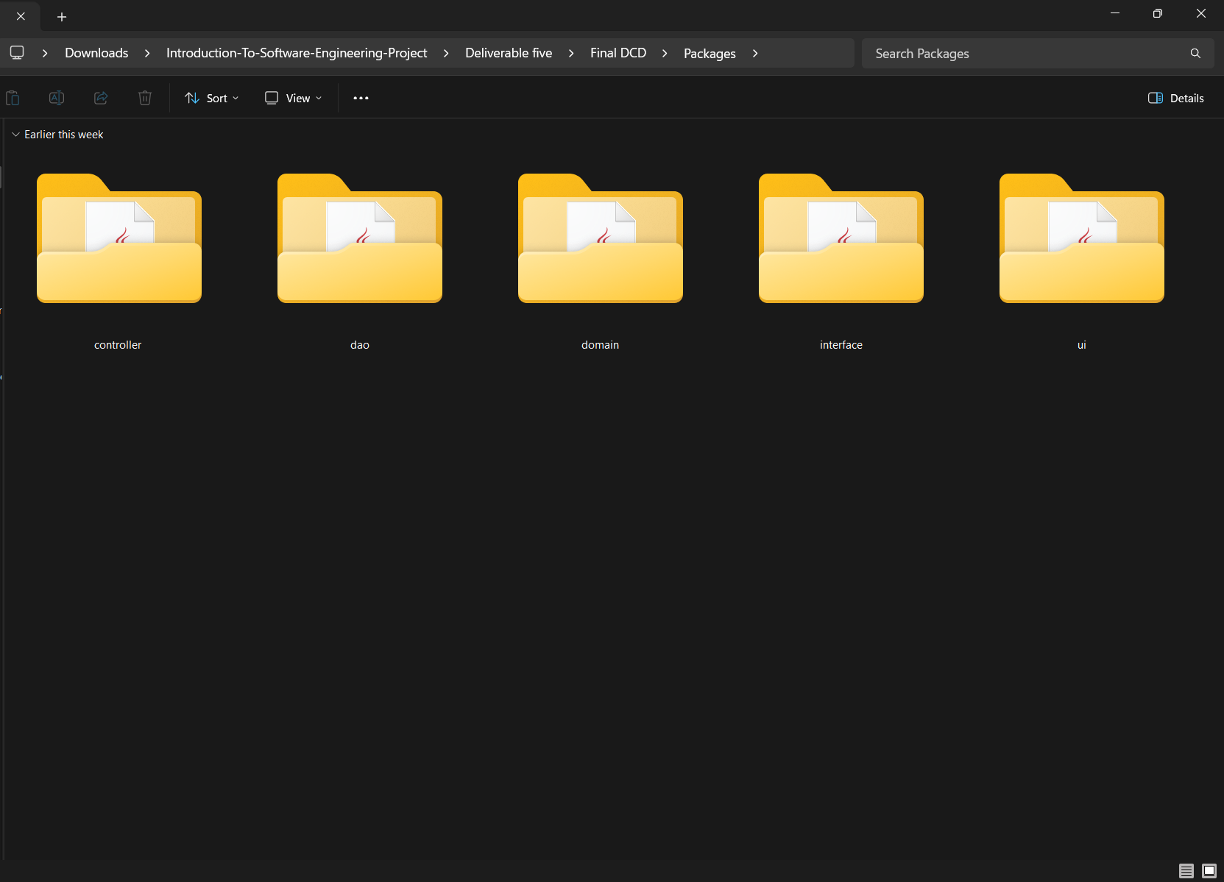
- Figure 40: (NetBeans package tree)
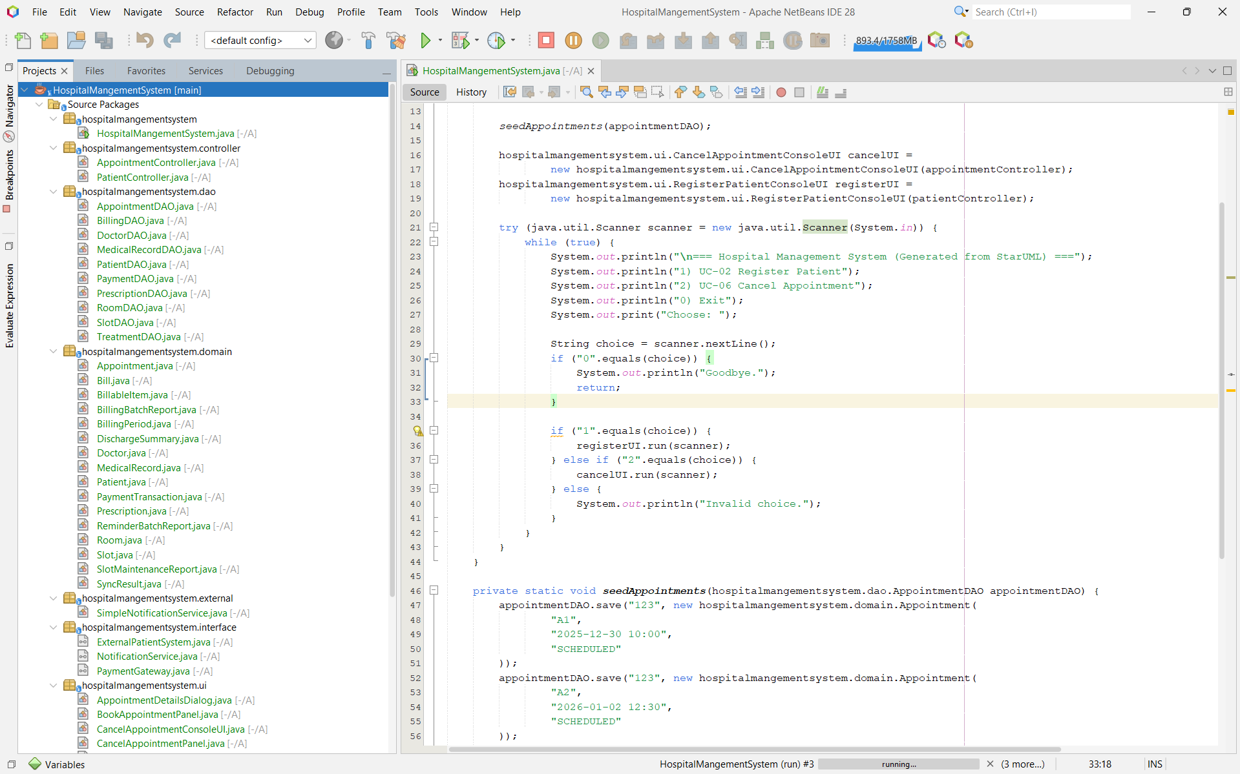

9.2 Implemented Use Cases
UC-02 Register Patient Information (Implemented)
- UI collects nationalId and name
- Controller validates and registers patient
- DAO persists using arrays
Figure 41: ( Running UC-02 success output)
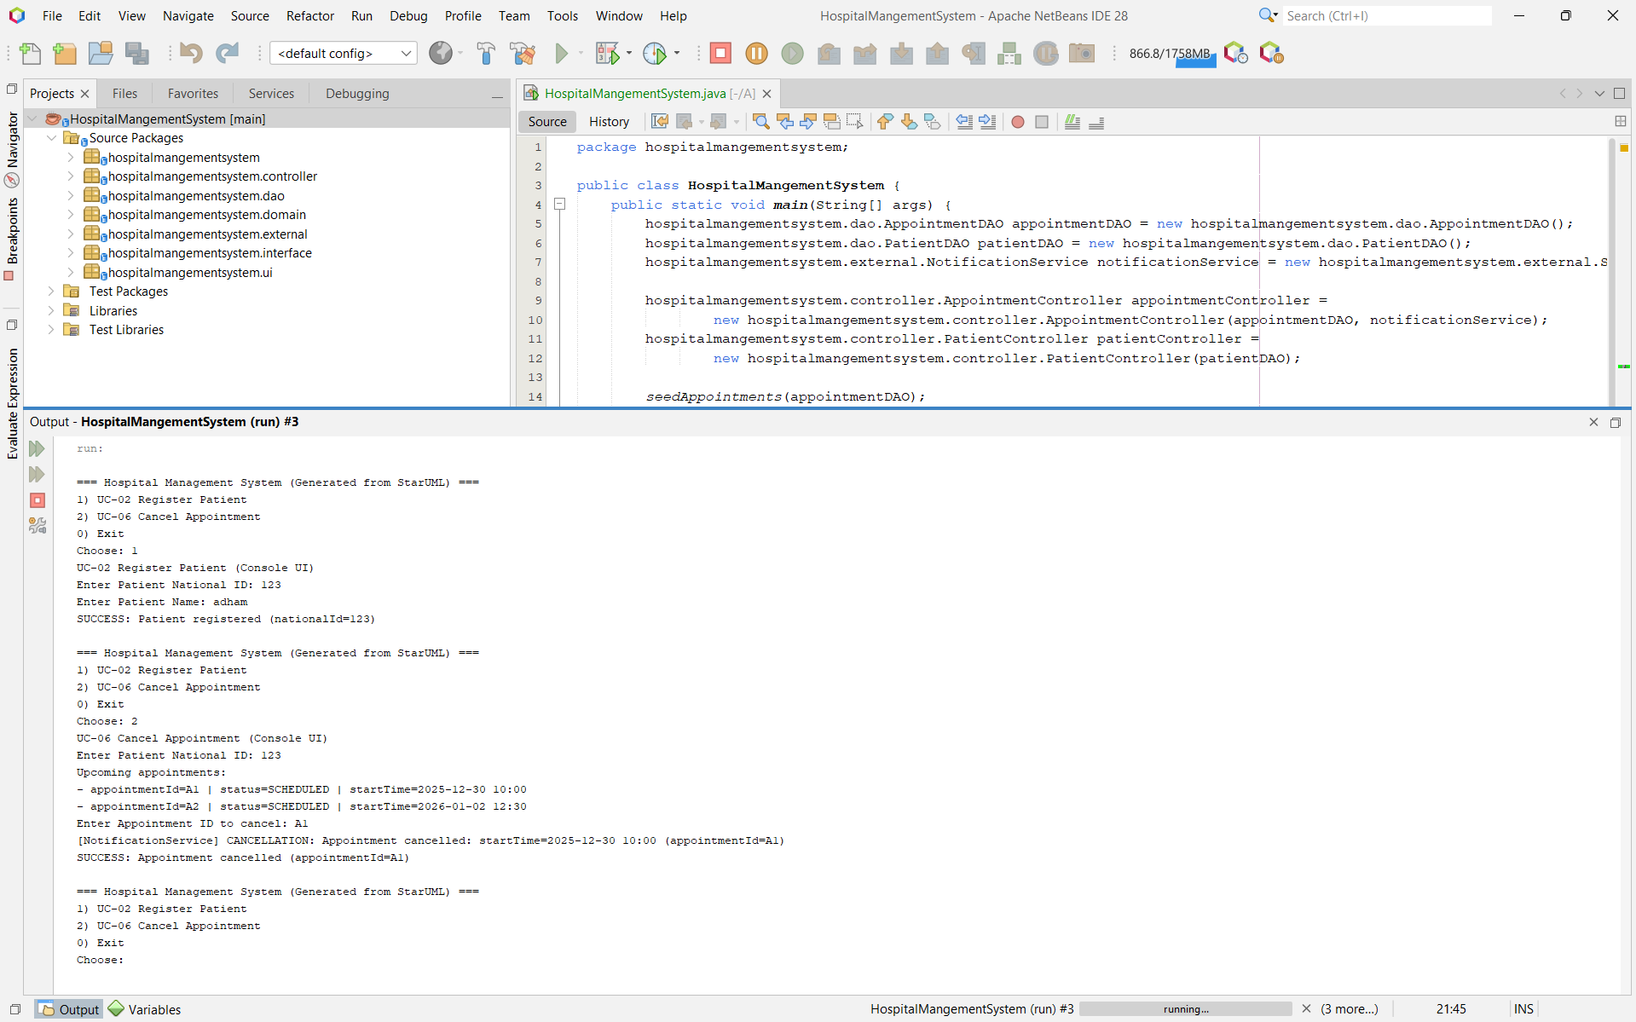
UC-06 Cancel Appointment (Implemented)
- UI lists upcoming appointments
- Controller cancels selected appointment
- DAO updates status to CANCELLED
- Notification service sends cancellation message

9.3 “Database Interaction” via Array-Based DAOs
Persistence requirement is satisfied through arrays inside PatientDAO and AppointmentDAO.
- Figure 44: (Code snippet of PatientDAO array storage)
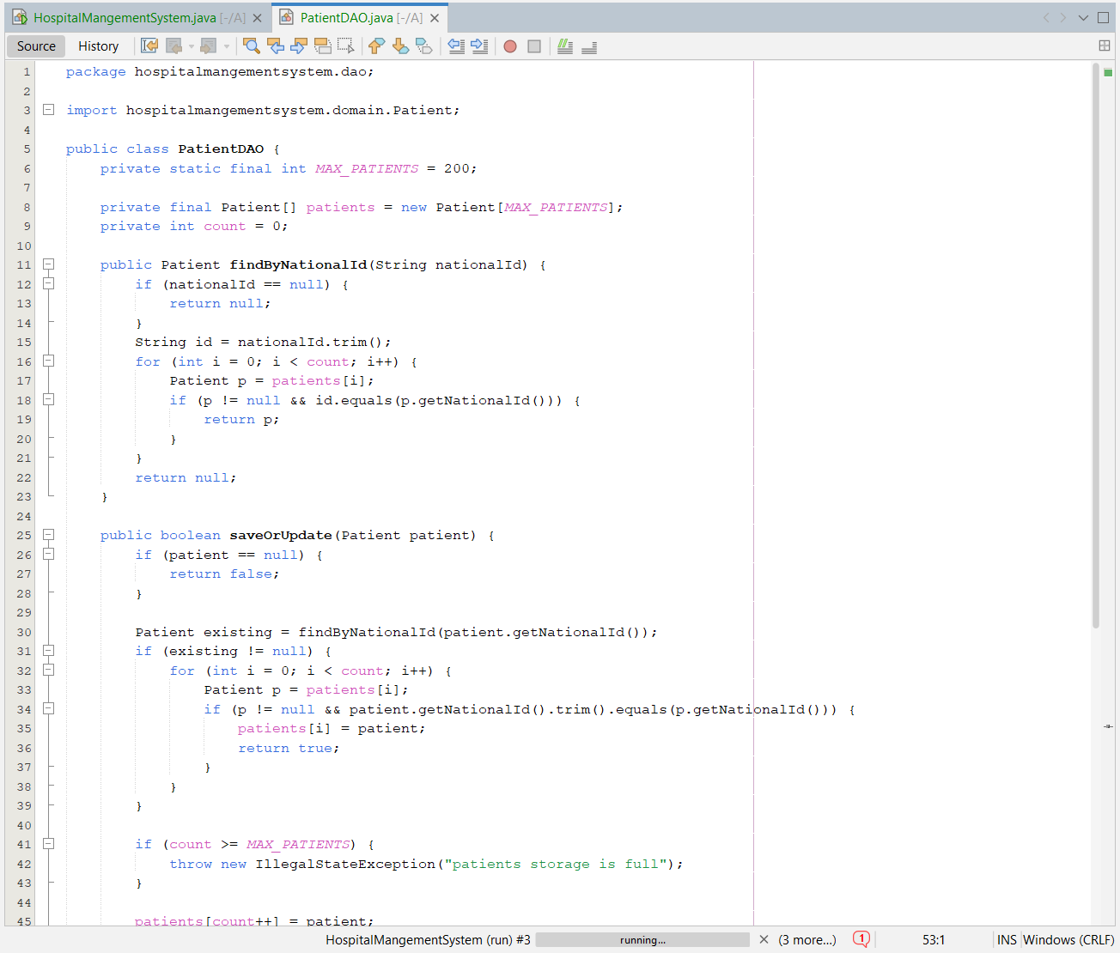
- Figure 45: (AppointmentDAO array storage)
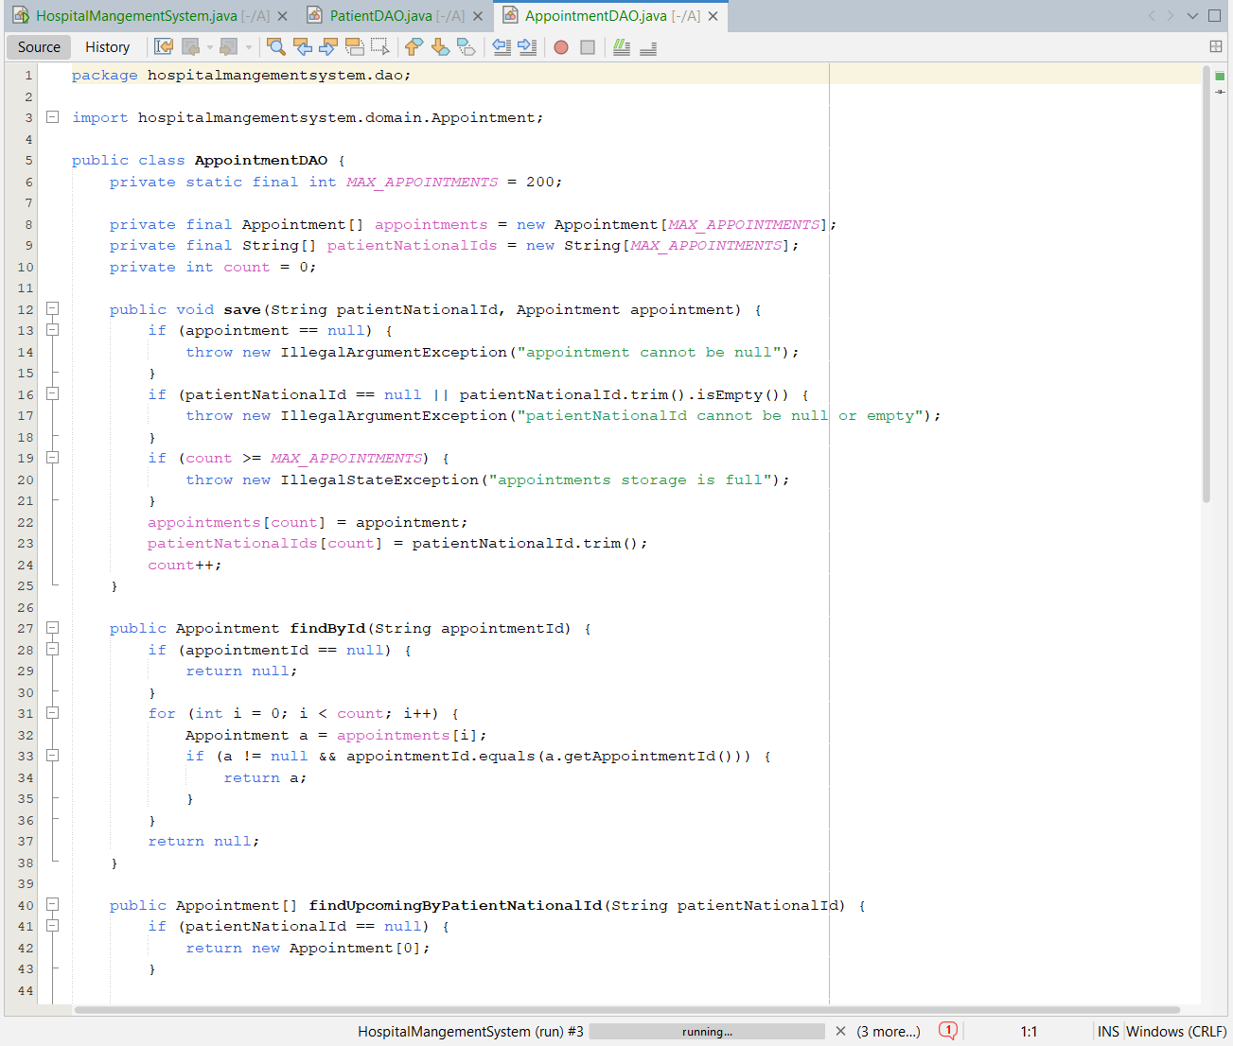

10. Evidence Checklist (Screenshots)
- Figure 46: NetBeans Clean and Build → BUILD SUCCESSFUL
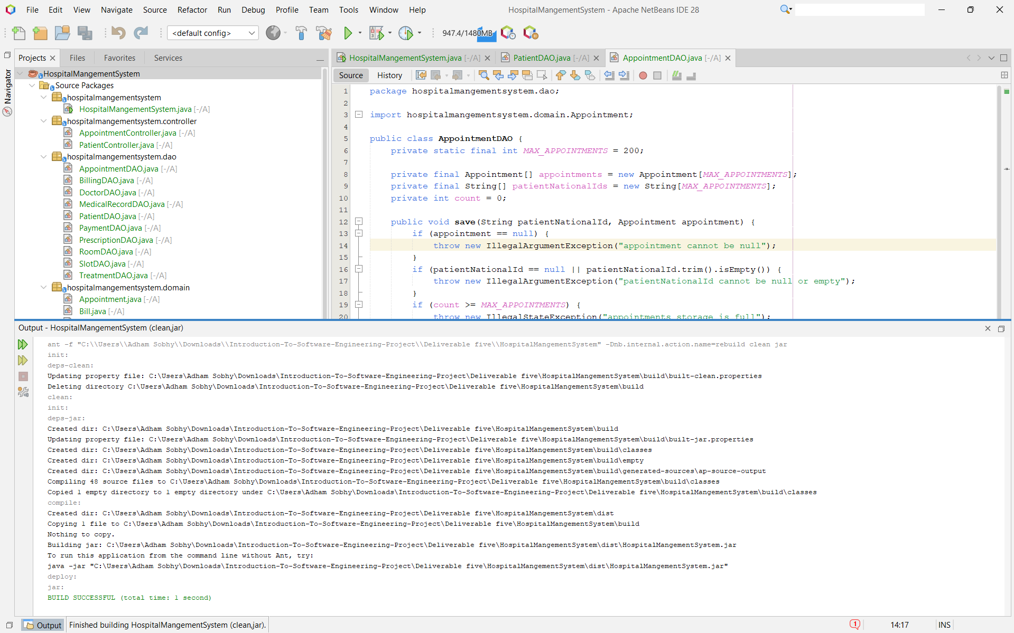

11. Jira / GitHub Evidence
- Jira board/timeline: (insert screenshot or link)
- GitHub repo: (insert link)
- Commit history: (insert screenshot)

12. Conclusion
Deliverable 5 produced a complete use-case driven OO design for HMS. We classified use cases, selected 12 core use cases across complexity levels, and applied CRC/communication/sequence realization techniques accordingly. We consolidated the extracted operations into the final DCD and validated architecture using the package diagram.
Finally, we performed StarUML model-to-code transformation and implemented UC-02 and UC-06 as a runnable NetBeans walking skeleton using strict layered architecture and array-based DAO persistence, satisfying deliverable constraints.

Appendix A — Run Instructions (NetBeans)
Open project HospitalMangementSystem in NetBeans
Right-click project → Clean and Build
Run main: hospitalmangementsystem.HospitalMangementSystem
Menu:
1 → UC-02
2 → UC-06
0 → Exit

Appendix B — Submission Checklist
( ) PDF report with diagrams inserted inline (Figures 1–49)
( ) StarUML .mdj file included
( ) NetBeans project folder included
( ) Build success screenshot included
( ) UC-02 and UC-06 run screenshots included
( ) Jira/GitHub evidence included

